Table of Contents

Module 0 Introduction 2

Welcome to the course 2

Introduction 2

Course Introduction 2

About this course 2

Course Agenda 2

Course Audience 6

Course Prerequisites 6

Microsoft Certification 7

Module 1 Getting Started with Microsoft Data Analytics 8

Data analytics and Microsoft 8

Introduction 8

Overview of data analysis 9

Roles in data 11

Tasks of a data analyst 13

Lesson Review 16

Knowledge Check 17

Getting Started with Power BI 17

Introduction 17

Use Power BI 19

Building Blocks of Power BI 20

Exercise touring and using Power-BI 25

Lesson Review 29

Knowledge Check 31

Module 2 Get Data in Power BI 33

# Module 0 Introduction

## Welcome to the course

### Introduction

This course has been created by the Microsoft World Wide Learning team to support exam DA-100: Analyzing Data with Power BI.

#### Learning Objectives

In this module you will learn:

* About this course
* About the audience
* Course pre-requisites
* Understand the DA-100 certification

### Course Introduction

This module provides an overview of the following:

* About this course
* Course agenda
* Course audience
* Course pre-requisites
* DA100: Analyzing Data with Power BI

### About this course

In this course, you will learn about, and apply, the various methods and best practices that are in line with business and technical requirements for ingesting, modeling, visualizing, and analyzing data.

You will also learn about the management aspects of Power BI, including workspaces and datasets, and then learn how to share, distribute, and appropriately secure Power BI assets.

### Course Agenda

At the end of this course, the student will learn:

#### Module 1: Get Started with Microsoft Data Analytics

This module explores the different roles in the data space, outlines the important roles and responsibilities of a Data Analysts, and then explores the landscape of the Power BI portfolio.

Module Objectives:

At the end of this module, the students will be able to:

* Identify the different roles in the data space
* Identify the tasks that are performed by a Data Analyst
* Describe the Power BI landscape of products and services
* Tour the Power BI Service

#### Module 2: Get Data in Power BI

This module explores identifying and retrieving data from various data sources. You will also learn the options for connectivity and data storage, and understand the difference and performance implications of importing or connecting directly to data.

Module Objectives:

At the end of this module, the students will be able to:

* Identify and retrieve data from different data sources
* Understand the different connection methods and their performance implications
* Optimize query performance
* Resolve data import errors

#### Module 3: Clean, Transform, and Load Data in Power BI

This module teaches you the process of profiling and understanding the condition of the data. They will learn how to identify anomalies, look at the size and shape of their data, and perform the proper data cleaning and transforming steps to prepare the data for loading into the model.

Module Objectives:

At the end of this module, the students will be able to:

* Apply data shape transformations
* Enhance the data structure
* Profile and examine the data

#### Module 4: Design a Data Model in Power BI

This module teaches you the fundamental concepts of designing and developing a data model for proper performance and scalability. This module will also help you understand and tackle many of the common data modeling issues, including relationships, security, and performance.

Module Objectives:

At the end of this module, the students will be able to:

* Understand the basics of data modeling
* Define relationships and their cardinality
* Implement Dimensions and hierarchies
* Create histograms and rankings

#### Module 5: Creating Measures using DAX in Power BI

This module introduces you to the world of DAX and its true power for enhancing a model. You will learn about aggregations and the concepts of Measures, calculated columns and tables, and Time Intelligence functions to solve calculation and data analysis problems.

Module Objectives:

At the end of this module, the students will be able to:

* Understand DAX
* Use DAX for simple formulas and expressions.
* Create calculated tables and columns
* Build simple measures
* Work with Time Intelligence and Key Performance Indicators

#### Module 6: Optimizing Model Performance

In this module you are introduced to the steps, processes, concepts, and data modeling best practices necessary to optimize a data model for enterprise-level performance.

Module Objectives:

At the end of this module, the students will be able to:

* Understand the importance of variables
* Enhance the data model
* Optimize storage
* Implement aggregations

#### Module 7: Creating Reports

This module introduces you to the fundamental concepts and principles of designing and building a report, including selecting the correct visuals, designing a page layout, and applying basic but critical functionality This important topic of designing for accessibility is also covered.

Module Objectives:

At the end of this module, the students will be able to:

* Design a page layout
* Select and add appropriate visualization type
* Add basic report functionality
* Add basic report navigation and interactions
* Improve report performance
* Design for accessibility

#### Module 8: Creating Dashboards

In this module you will learn about dashboards, and how to tell a compelling story through the use of dashboards. You will be introduced to features and functionality and how to enhance dashboards for usability and insights.

Module Objectives:

At the end of this module, the students will be able to:

* Create a dashboard
* Understand real-time dashboards
* Enhance the dashboard usability

#### Module 9: Create Paginated Reports in Power BI

This module will teach you about paginated reports, including what they are how they fit into the Power BI spectrum. You will then learn how to build and publish a report.

Module Objectives:

At the end of this module, the students will be able to:

* Explain paginated reports
* Create a paginated report
* Create and configure a data source and dataset.
* Work with charts and tables on the report.
* Publish the report.

#### Module 10: Perform Advanced Analytics

This module helps you apply additional features to enhance the report for analytical insights in the data, equipping you with the steps to use the report for actual data analysis. You will also perform advanced analytics using AI visuals on the report for even deeper and meaningful data insights.

Module Objectives:

At the end of this module, the students will be able to:

* Explore statistical summary
* Use the Analyze feature
* Identify outliers in the data
* Conduct time-series analysis
* Use the AI visuals
* Use the Advanced Analytics custom visual

#### Module 11: Create and Manage Workspaces

This module will introduce you to Workspaces, including how to create and them. You will also learn how to share content, including reports and dashboards, and then learn how to distribute an App.

Module Objectives:

At the end of this module, the students will be able to:

* Create and manage a workspace
* Understand workspace collaboration
* Monitor usage and performance
* Distribute an App

#### Module 12: Manage Datasets in Power BI

In this module you will learn the concepts of managing Power BI assets, including datasets and workspaces. You will also publish datasets to the Power BI service, then refresh and secure them.

Module Objectives:

At the end of this module, the students will be able to:

* Configure dataset refresh
* Create and work with parameters
* Manage datasets
* Troubleshoot gateway connectivity

#### Module 13: Row-level Security

This module teaches you the steps for implementing and configuring security in Power BI to secure Power BI assets.

Module Objectives:

At the end of this module, the students will be able to:

* Understand aspects of Power BI security
* Configure static and dynamic row-level

### Course Audience

#### Primary Audience

The audience for this course are data professionals and business intelligence professionals who want to learn how to accurately perform data analysis using Power BI.

#### Secondary Audience

The secondary audience for this course are individuals who develop reports that visualize data from the data platform technologies that exist on both in the cloud and on-premises.

### Course Prerequisites

In addition to their professional experience, students who take this training should have technical knowledge equivalent to the following courses:

* Azure Fundamentals

### Microsoft Certification

#### Data Analyst Associate

Data Analysts enable businesses to maximize the value of their data assets using Power BI by providing meaningful business value and analysis through easy-to-understand visualizations. To gain this certification, you must bass the following exam:

* DA-100: Analyzing Data with Power BI

This course is used to prepare for exam DA-100.

# Module 1 Getting Started with Microsoft Data Analytics

## Data analytics and Microsoft

### Introduction

As a data analyst, you are on a journey. Think about all the data that is being generated each day and that is available in an organization, from transactional data in a traditional database, telemetry data from services you use, to signals you get from different areas like social media.

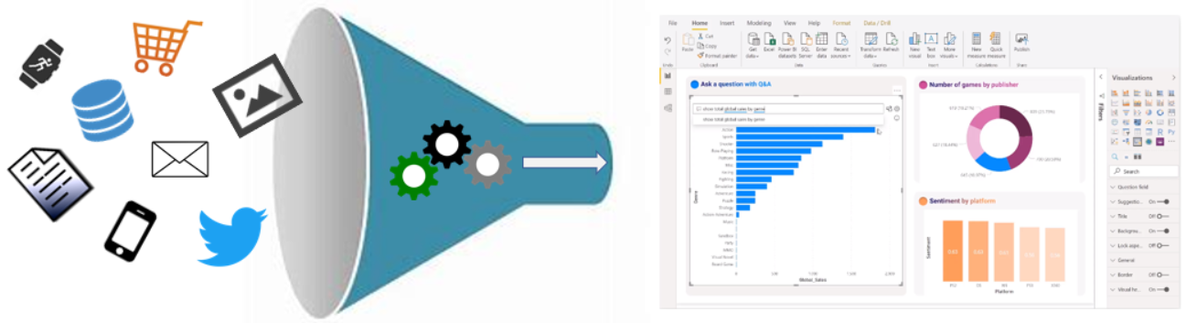

For example, retail businesses of today collect and store massive amounts of data, which track the items you browsed and purchased, the pages you've visited on their site, the aisles you purchase products from, your spending habits, and much more.

With data and information as the most strategic asset of a business, the underlying challenge that organizations have today is understanding and using their data to positively affect change within the business. Yet, businesses continue to struggle to use their data in a meaningful and productive way, which impacts their ability to act.

A retail business should be able to use their vast amounts of data and information in such a way that impacts the business, including tracking inventory, identifying purchase habits, detecting end-user trends and patterns, recommending purchases, determining price optimizations, and identifying and stopping fraud. You may also be searching for daily/monthly sale patterns. Day over day, week over week and month over month are also common segments to invstigate. How have sales compared to where we were in the same week last year?

They key to unlocking all this data is being able to tell a story with it. In today's highly competitive and fast-paced business world, crafting reports that tell that story is what helps business leaders to really take action on the data. Business decision makers depend on an accurate story to drive better business decisions. The faster a business can make precise decisions, the more competitive they will be and the better advantage they will have. Without the story, it is hard to understand what the data is trying to tell you.

Having data alone is not enough. You need to be able to act on the data to effect change within the business. Whether that is reallocating resources within the business to accommodate a need or being able to identify a failing campaign and knowing when to change course. This is where telling a story with your data is important.

The underlying challenge that businesses face today is understanding and using their data in such a way that impacts their business and ultimately their bottom line. You need to be able to interpret data, clearly understand the meaning behind the metrics, and facilitate trusted business decisions.

This sounds daunting but know that you are not alone. You will want to partner with the data professionals within your organization, such as data engineers and data scientists, to help get the data you need to tell that story. Have them take part in that data journey with you.

Your journey of telling a story with data also ties into building that data culture within your organization. While telling the story is important, where that story is told is also crucial, making sure the story is told to the right people. Also, make sure people can discover the story, they know where to find it, and that it is part of the regular interactions.

Data analysis exists to help overcome these challenges and pain points, assisting businesses to find insights and uncover hidden value in troves of data through story telling. As you read on, you will learn how you will utilize and apply analytical skills to go beyond a single report and help to impact and influence your organization by telling stories with data and driving that data culture.

### Overview of data analysis

Before data can be used to tell a story, it must first be run through a process that makes it usable in the story. Thus, data analysis is the process of identifying, cleaning, transforming, and modeling data to discover meaningful and useful information. The data is then crafted into a story via reports for analysis to support the critical decision-making process.

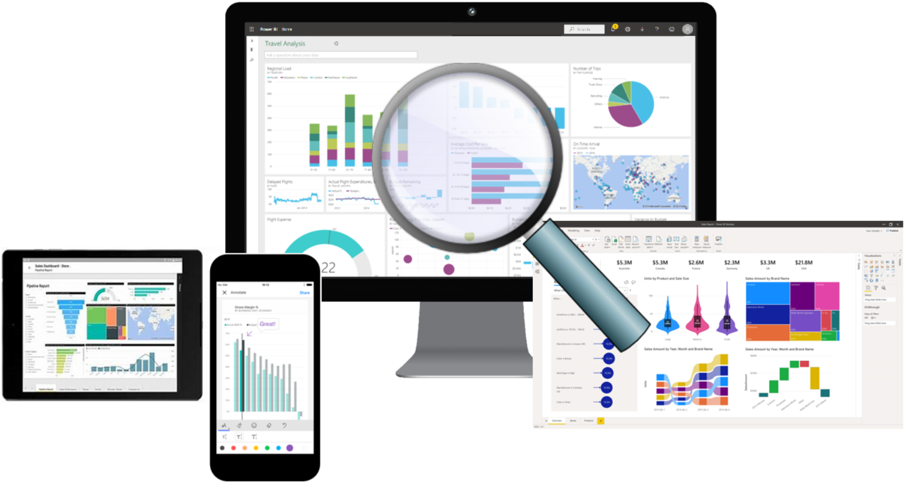

As the world becomes more data-driven, storytelling through data analysis is becoming a more vital component and aspect of businesses large and small and is the reason organizations continue to hire data analysts.

Data-driven businesses make decisions based on the story their data tells, and in today's data-driven world, data is not being used to its full potential, a challenge that most business face today. Data analysis is and should be a critical aspect of all organizations to determine the impact to their business, including customer sentiment, market and product research, identify trends, or any other data insights.

While the process of data analysis focuses on the tasks of cleaning, modeling, and visualizing data, the concept of data analysis and how it is important to business should not be understated. To analyze data, core components of analytics are divided in the following categories:

#### Descriptive analytics

Descriptive analytics helps answer questions about what has happened, based on historical data. Descriptive analytics techniques summarize large datasets to describe outcomes to stakeholders.

By developing KPIs (Key Performance Indicators), these strategies can help track the success or failure of key objectives. Metrics such as return on investment (ROI) are used in many industries. Specialized metrics are developed to track performance in specific industries.

Examples of descriptive analytics include generating reports to provide a view of an organization's sales and financial data.

#### Diagnostic analytics

Diagnostic analytics helps answer questions about why things happened. Diagnostic analytics techniques supplement more basic descriptive analytics. They take the findings from descriptive analytics and dig deeper to find the cause. The performance indicators are further investigated to discover why they got better or worse. This generally occurs in three steps:

* Identify anomalies in the data. These may be unexpected changes in a metric or a particular market.
* Collect data that's related to these anomalies.
* Use statistical techniques to discover relationships and trends that explain these anomalies.

#### Predictive analytics

Predictive analytics helps answer questions about what will happen in the future. Predictive analytics techniques use historical data to identify trends and determine if they're likely to recur. Predictive analytical tools provide valuable insight into what may happen in the future. Techniques include a variety of statistical and machine learning techniques such as neural networks, decision trees, and regression.

#### Prescriptive analytics

Prescriptive analytics helps answer questions about what actions should be taken to achieve a goal or target. By using insights from predictive analytics, data-driven decisions can be made. This technique allows businesses to make informed decisions in the face of uncertainty. Prescriptive analytics techniques rely on machine learning strategies to find patterns in large datasets. By analyzing past decisions and events, the likelihood of different outcomes can be estimated.

#### Cognitive analytics

Cognitive analytics attempts to draw inferences from existing data and patterns, derive conclusions based on existing knowledge bases, and then add these findings back into the knowledge base for future inferences, a self-learning feedback loop. Cognitive analytics helps you to learn what might happen if circumstances change, and how you might handle these situations.

Inferences aren't structured queries based on a rules database, rather they're unstructured hypotheses gathered from several sources and expressed with varying degrees of confidence. Effective cognitive analytics depends on machine learning algorithms. It uses several NLP (Natural Language Processing) concepts to make sense of previously untapped data sources, such as call center conversation logs and product reviews.

#### Example

By enabling reporting and data visualizations, a retail business uses descriptive analytics to look at patterns of purchases from previous years to determine what products might be popular next year. They might also look at supporting data to understand why a particular product was popular and if that trend is continuing, determine whether they need to continue to stock that product.

A business might determine that a certain product was popular over a certain timeframe and use analysis to determine whether any marketing efforts or online social activities contributed to the sales increase.

An underlying facet of data analysis is that businesses need to be able to trust its data, and as a practice, the data analysis process take data from trusted sources and shapes it into something that is consumable, meaningful and easily understood from which business decisions can be made. Data analysis enables businesses to fully understand their data through data-driven processes and decisions, allowing businesses to be confident in their decisions.

As the amount of data grows, so does the need for data analysts. A data analyst knows how to organize information and distill it into something meaningful and understandable. A data analyst knows how to gather the right data and what to do with it, i.e., the mission of making sense of the data in your data swamp.

### Roles in data

As mentioned before, you are not alone. This is a journey and it usually doesn't start with you. The data must come from somewhere. And getting that data into a spot that is usable by you takes some effort and more than likely out of your scope. Especially when we think of the enterprise.

Today's applications and projects can be large and intricate, often utilizing the skills and knowledge of numerous individuals. Each person brings a unique talent and expertise to the table, working together and coordinating tasks and responsibilities in order to see a project through from concept to production.

It wasn't too long ago when roles such as business analysts and business intelligence developers were the de facto norm for data processing and understanding. But the growth and explosion of both the size of data and the different types of data has caused these roles to evolve into more specialized set of skills that modernize and streamline the processes of data engineering and analysis.

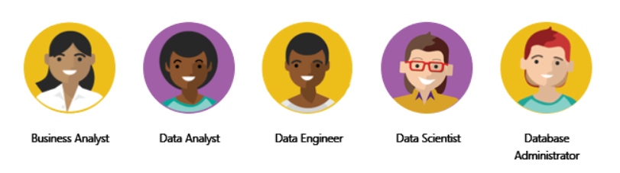

The following highlights the different roles in data and the specific responsibility in the overall, end-to-end spectrum of data discovery and understanding.

* Business analyst
* Data analyst
* Data engineer
* Data scientist
* Database administrator

#### Business Analyst

While there are some similarities between a data analyst and business analyst, the key differentiator between the two roles is what they do with data. A business analyst is closer to the business itself and is a specialist on interpreting the data that comes from the visualization. Often the data analyst and business analyst could be the accountability of a single person.

#### Data Analyst

A data analyst enables businesses to maximize the value of their data assets through visualization and reporting tools such as Power BI. Data analysts are responsible for profiling, cleaning, and transforming data, designing, and building scalable and performant data models, and enabling and implementing the advanced analytics capabilities into reports for analysis. They work with the appropriate stakeholders to identify appropriate and necessary data and reporting requirements and then are tasked with turning raw data into relevant and meaningful insights.

A data analyst is also responsible for the management of Power BI assets, including reports, dashboards, workspaces, and the underlying datasets used in the reports. They are tasked with implementing and configuring proper security procedures, in conjunction with stakeholder requirements, to ensure the safekeeping of all Power BI assets and their data.

Data analysts work with data engineers to determine and locate appropriate data sources that meet stakeholder requirements, and work with both the data engineer and database administrator to ensure the data analyst has proper access to the needed data sources. The data analyst also works with the data engineer to identify new processes or improve existing processes for collecting data for analysis.

#### Data Engineer

Data engineers provision and set up data platform technologies that are on-premises and in the cloud. They manage and secure the flow of structured and unstructured data from multiple sources. The data platforms they use can include relational databases, nonrelational databases, data streams, and file stores. Data engineers also ensure that data services securely and seamlessly integrate across data services.

Primary responsibilities of data engineers include the use of on-premises and cloud data services and tools to ingest, egress, and transform data from multiple sources. Data engineers collaborate with business stakeholders to identify and meet data requirements. They design and implement solutions.

While there might be some alignment in the tasks and responsibilities of a data engineer and a database administrator, a data engineer's scope of work goes well beyond looking after a database and the server where it's hosted, and likely doesn't include the overall operational data management.

A data engineer adds tremendous value to both business intelligence and data science projects. When the data engineer brings data together, often described as data wrangling, projects move more quickly because data scientists can focus on their own areas of work.

As a data analyst, you work close with a data engineer in making sure that you can access the variety of structured and unstructured data sources, as they will support you in optimizing data models which are typically served from a modern data warehouse or data lake.

Both database administrators and business intelligence professionals can easily transition to a data engineer role. They just need to learn the tools and technology that are used to process large amounts of data.

#### Data Scientist

Data scientists perform advanced analytics to extract value from data. Their work can vary from descriptive analytics to predictive analytics. Descriptive analytics evaluate data through a process known as exploratory data analysis (EDA). Predictive analytics are used in machine learning to apply modeling techniques that can detect anomalies or patterns. These are an important part of forecast models.

Descriptive and predictive analytics are just one aspect of data scientists' work. Some data scientists might even work in the realms of deep learning, iteratively experimenting to solve a complex data problem by using customized algorithms.

Anecdotal evidence suggests that most of the work in a data science project is spent on data wrangling and feature engineering. Data scientists can speed up the experimentation process when data engineers use their skills to successfully wrangle data.

On the surface, it might seem that a data scientist and data analyst are far apart in the work they do, but this not the case. A data scientist looks at data to determine the questions that need answers and often will devise a hypothesis or an experiment and turn to the data analyst to assist with the data visualization and reporting.

#### Database Administrator

A database administrator implements and manages the operational aspects of cloud-native and hybrid data platform solutions built on Microsoft Azure data services and Microsoft SQL Server. They are responsible for the overall availability and consistent performance and optimizations of the database solutions. They work with stakeholders to identify and implement the policies, tools, and processes for data backup and recovery plans.

The role of a database administrator is different from the role of a data engineer. A database administrator monitors and manages the overall health of a database and the hardware it resides on, whereas a data engineer is involved in the process of data wrangling, i.e., ingesting, transforming, validating, and cleaning data to meet business needs and requirements.

The database administrator is also responsible for managing the overall security of the data, granting and restricting user access and privileges to the data as determined by business needs and requirements.

### Tasks of a data analyst

Now that you've looked at the who and the what, it's time to look at the how. You already know that a data analyst is one of several critical roles in an organization, helping uncover and make sense of information to keep the company balanced and operating efficiently. As such, it's vital that you, as a data analyst, clearly understands your responsibility and the tasks that are performed on a near-daily basis. The skillset of a data analyst is essential in helping organizations gain valuable insights into the expanse of data they have, working closely with others in their respective roles in the organization to help bring to light valuable information.

As such, there are five key areas that you'll engage in during the data analysis process.

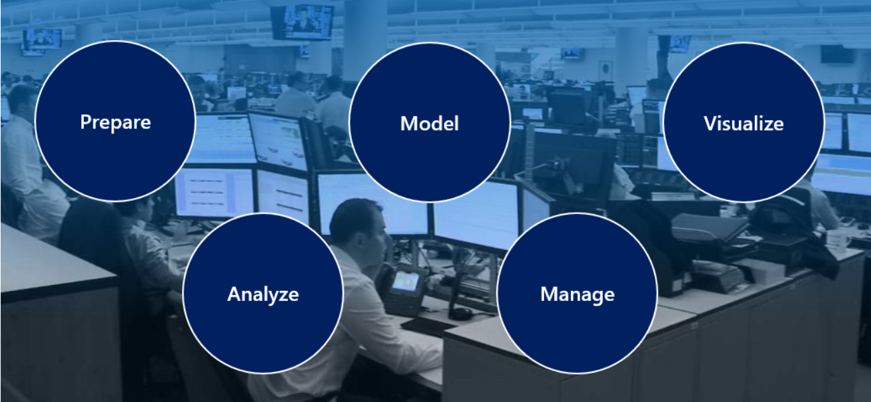

#### Prepare

As a data analyst, you'll probably spend most of your time split between the prepare and model tasks. Bad or incorrect data can have a major impact, resulting in invalid reports, a loss of trust, and can negatively affect business decisions, which lead to loss in revenue, a negative business impact, and more.

Long before a report can be created, data must be prepared. Data preparation is the process of profiling, cleaning, and transforming your data to get it ready to model and visualize.

Data preparation is the process of taking raw data and turning it into information that is trusted and understandable. It involves, among other things, ensuring the integrity of the data, correcting wrong or inaccurate data, identifying missing data, converting data from one structure to another or from one type to another, or even something as simple as making data more readable.

Data preparation also involves understanding “how” you're going to get and connect to the data and the performance implications of the decisions. When connecting to data, decisions need to be made to ensure models and reports meet, and perform to, acknowledged requirements and expectations.

Privacy and security are also important. This can include anonymizing data to avoid oversharing or preventing people from seeing personally identifiable information when it isn't needed. Or, removing that data completely if it doesn't fit in with the story you're trying to shape.

Data preparation can often be a lengthy process, which takes a data analyst through a series of steps and methods of preparing the data to put it in proper context and a state that eliminates poor data quality and allows it to be turned into valuable insights.

#### Model

Once the data is in a proper state, it's ready to be modeled. Data modeling is the process of determining how your tables are related to each other. This is done by defining, and creating, relationships between the tables. From there, you can enhance the model by defining metrics and adding custom calculations to enrich your data.

Creating an effective and proper data model is a vital and critical step in helping organizations understand and gain valuable insights into the data. An effective data model makes reports more accurate and truthful, allows the data to be explored faster and more efficient, allows the report authoring process to take less time, and makes future report maintenance easier.

It is important to remember that the model is another critical component that has a direct effect on the performance of your report and overall data analysis. A poorly designed model can have a drastically negative impact on the general accuracy and performance of your report. Conversely, a well-designed model with well-prepared data will ensure a properly performant and trusted report. This is even more the case when you are working with data at scale.

From a Power BI perspective, if your report is performing slowly, or your refreshes are taking a long time, you will probably need to revisit the data preparation and modeling tasks to optimize your report.

It should be noted that the process of preparing data and modeling data is an iterative process. Data preparation is the first task in data analysis. Understanding and preparing your data before you model it will make the modeling step much easier.

#### Visualize

This task is where you get to bring your data to life! The goal of the visualize task is to ultimately solve business problems. A well-designed report should tell a compelling and impactful story about that data, enabling business decision makers to quickly gain needed insights. Using appropriate visualizations and interactions, an effective report guides the reader through the content quickly and efficiently, allowing the reader to follow a narrative into the data.

The reports created during the visualization task help businesses and decision makers understand what that data means so that accurate and vital decisions can be made. Reports drive the overall actions, decisions, and behaviors of an organization, trusting and relying on the information discovered in the data.

The business may communicate that they need all data points on a given report to make decisions. As a data analyst, you should take the time to really understand the problem the business is trying to solve. Are all data point necessary? Too much data can make it difficult to spot the key points. Having a small and concise data story can help to find insights more quickly.

With the built-in AI capabilities in Power BI, data analysts can build powerful reports, without writing any code, that enables users to get insights and answers and find actionable insights. The AI capabilities in Power BI such as the built-in AI visuals enables the discovering of data simply by asking questions, using the Quick Insights feature, or creating machine learning models directly within Power BI.

An important aspect of visualizing data is designing and creating reports for accessibility. As you build reports, it is important to think about those individuals who will be accessing and reading the reports. Reports should be designed with accessibility in mind from the outset so that no special adoptions are needed down the road and no rework is needed.

Many components of your report will help with storytelling. From a color scheme that is complimentary and accessible, fonts, and sizing, to picking the right visuals for what is being displayed, they all come together to tell that story.

#### Analyze

The Analyze task is the important step of understanding and interpreting the information that is displayed on the report. In your role as a data analyst, you should understand the analytical capabilities of Power BI and use those to find insights, identify patterns and trends, predict outcomes, and then communicate those insights in such a way that everyone can understand.

Advanced analytics enables businesses and organizations to ultimately drive better decisions throughout the business and create actionable insights and meaningful results. With advanced analytics, organizations can drill down into the data to predict future patterns and trends, identify activities and behaviors, and enable businesses to ask the appropriate questions about their data.

In the past, analyzing data was a difficult and intricate process typically carried out and performed by data engineers or data scientists, but today Power BI puts data analysis at your fingertips, simplifying the data analysis process. Users can quickly gain insights into their data using visuals and metrics directly from their desktop and publish those insights to dashboards so that others can find needed information.

This is another area where the AI integrations within Power BI can take your analysis to the next level. Integrations with Azure Machine Learning, cognitive services and those built-in AI visuals help to enrich your data and analysis.

#### Manage

There are many components in Power BI, including reports, dashboards, workspaces, datasets, and more. As a data analyst, you are responsible for the management of these Power BI assets, overseeing the sharing and distribution of items such as reports and dashboards, and ensuring the security of Power BI assets.

Apps can be a valuable distribution method for your content and allow for easier management for large audiences. This also allows you have custom navigation experiences and link to other assets within your organization to complement your reports.

The management of your content helps to foster collaboration between teams and individuals. Sharing and discovery of your content is important for the right people to get the answers they need. Ensuring items are secure is as important. You want to make sure the right people have access and that you are not leaking data past the correct stakeholders.

Proper management can also help reduce data silos within your organization. Data duplication can make things hard to manage as well as introduce data latency when resources are overused. Power BI helps in reducing data silos with the use of shared datasets. Reuse of data that you have prepared and modeled. For key business data, endorsing a dataset as certified can help to ensure trust in that data.

The management of Power BI assets helps reduce the duplication of efforts and ensures the security of the data.

### Lesson Review

In this module, you learned that the role of data analyst is vital to the success of an organization, and the tasks they perform ensure that the business decisions made are based of trusted data. You also learned about the different roles in data and how they work closely with a data analyst to deliver valuable insights into a business's data assets.

### Knowledge Check

#### Question 1

Which data role enables advanced analytics capabilities through reports and visualizations?

* Data analyst
* Data scientist
* Data engineer

#### Question 2

Which data analyst task has critical performance impact on reporting and data analysis?

* Analyze
* Visualize
* Model

#### Question 3

What is a key benefit of data analysis?

* Decisive analytics
* Informed business decisions
* Complex reports

## Getting Started with Power BI

### Introduction

**Microsoft Power BI** is a collection of software services, apps, and connectors that work together to turn your unrelated sources of data into coherent, visually immersive, and interactive insights. Whether your data is a simple Microsoft Excel workbook, or a collection of cloud-based and on-premises hybrid data warehouses, Power BI lets you easily connect to your data sources, visualize (or discover) what's important, and share that with anyone or everyone you want.

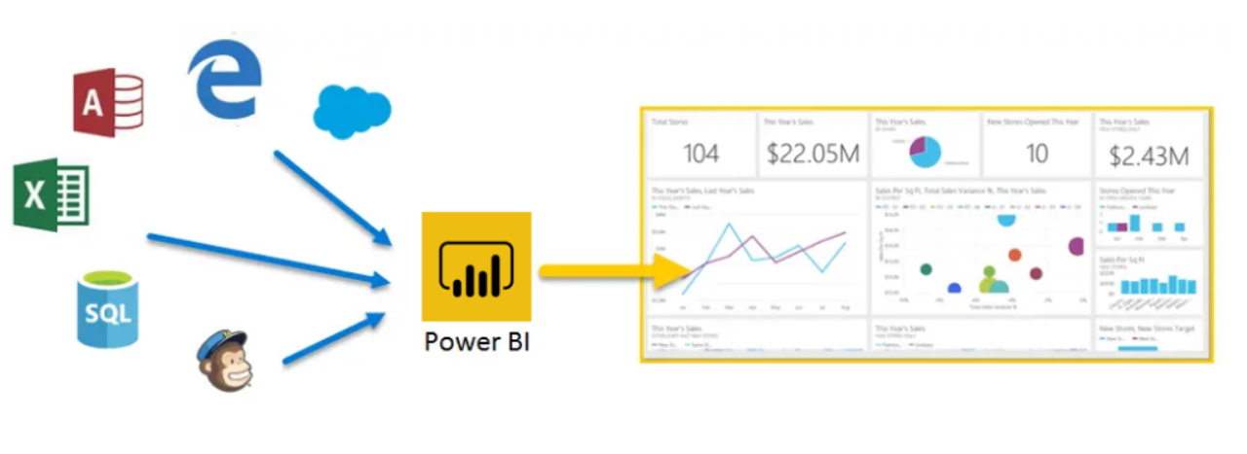

Power BI can be simple and fast, capable of creating quick insights from an Excel workbook or a local database. But Power BI is also robust and enterprise-grade, ready not only for extensive modeling and real-time analytics, but also for custom development. Therefore, it can be your personal report and visualization tool, but can also serve as the analytics and decision engine behind group projects, divisions, or entire corporations.

If you're a beginner with Power BI, this module will get you going. If you're a Power BI veteran, this module will tie concepts together and fill in the gaps.

#### The parts of Power BI

Power BI consists of a Microsoft Windows desktop application called **Power BI Desktop**, an online SaaS (Software as a Service) service called the **Power BI service**, and mobile Power BI **apps** that are available on any device, with native mobile BI apps for Windows, iOS, and Android.

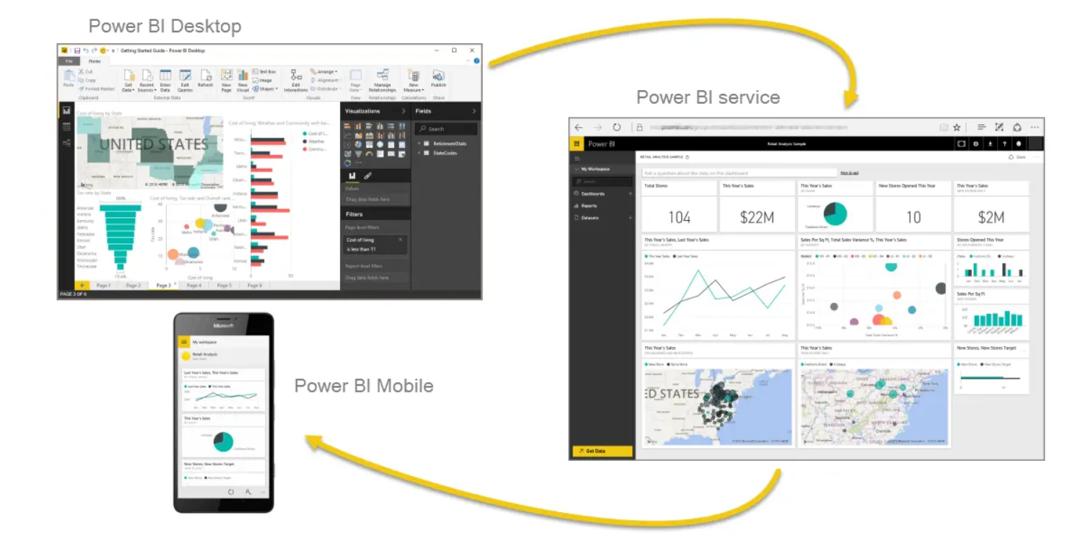

These three elements—**Desktop**, the **service**, and **Mobile** apps—are designed to let people create, share, and consume business insights in the way that serves them, or their role, most effectively.

#### How Power BI matches your role

How you use Power BI might depend on your role on a project or a team. And other people, in other roles, might use Power BI differently, which is just fine.

For example, you might view reports and dashboards in the Power BI service, and that might be all you do with Power BI. But your number-crunching, business-report-creating coworker might make extensive use of Power BI Desktop (and publish Power BI Desktop reports to the Power BI service, which you then use to view them). And another coworker, in sales, might mainly use her Power BI phone app to monitor progress on her sales quotas and drill into new sales lead details.

You also might use each element of Power BI at different times, depending on what you're trying to achieve, or what your role is for a given project or effort.

Perhaps you view inventory and manufacturing progress in a real-time dashboard in the service, and also use Power BI Desktop to create reports for your own team about customer engagement statistics. How you use Power BI can depend on which feature or service of Power BI is the best tool for your situation. But each part of Power BI is available to you, which is why it's so flexible and compelling.

We discuss these three elements—Desktop, the service, and Mobile apps—in more detail later. In upcoming units and modules, we'll also create reports in Power BI Desktop, share them in the service, and eventually drill into them on our mobile device.

#### Download Power BI Desktop

You can download Power BI Desktop from the web or as an app from the Microsoft Store on the Windows tab.



#### Sign in to Power BI service

Before you can sign in to Power BI, you'll need an account. To get a free trial, go to <app.powerbi.com> and sign up with your email address.

For detailed steps on setting up an account, see Sign in to Power BI service

#### The flow of work in Power BI

A common flow of work in Power BI begins in Power BI Desktop, where a report is created. That report is then published to the Power BI service and finally shared, so that users of Power BI Mobile apps can consume the information.

It doesn't always happen that way, and that's okay. But we'll use that flow to help you learn the different parts of Power BI and how they complement each other.

Okay, now that we have an overview of this module, what Power BI is, and its three main elements, let's take a look at what it's like to use Power BI.

### Use Power BI

Now that we've introduced the basics of Microsoft Power BI, let's jump into some hands-on experiences and a guided tour.

The activities and analyses that you'll learn with Power BI generally follow a common flow. The common flow of activity looks like this:

1. Bring data into Power BI Desktop, and create a report.
2. Publish to the Power BI service, where you can create new visualizations or build dashboards.
3. Share dashboards with others, especially people who are on the go.
4. View and interact with shared dashboards and reports in Power BI Mobile apps.

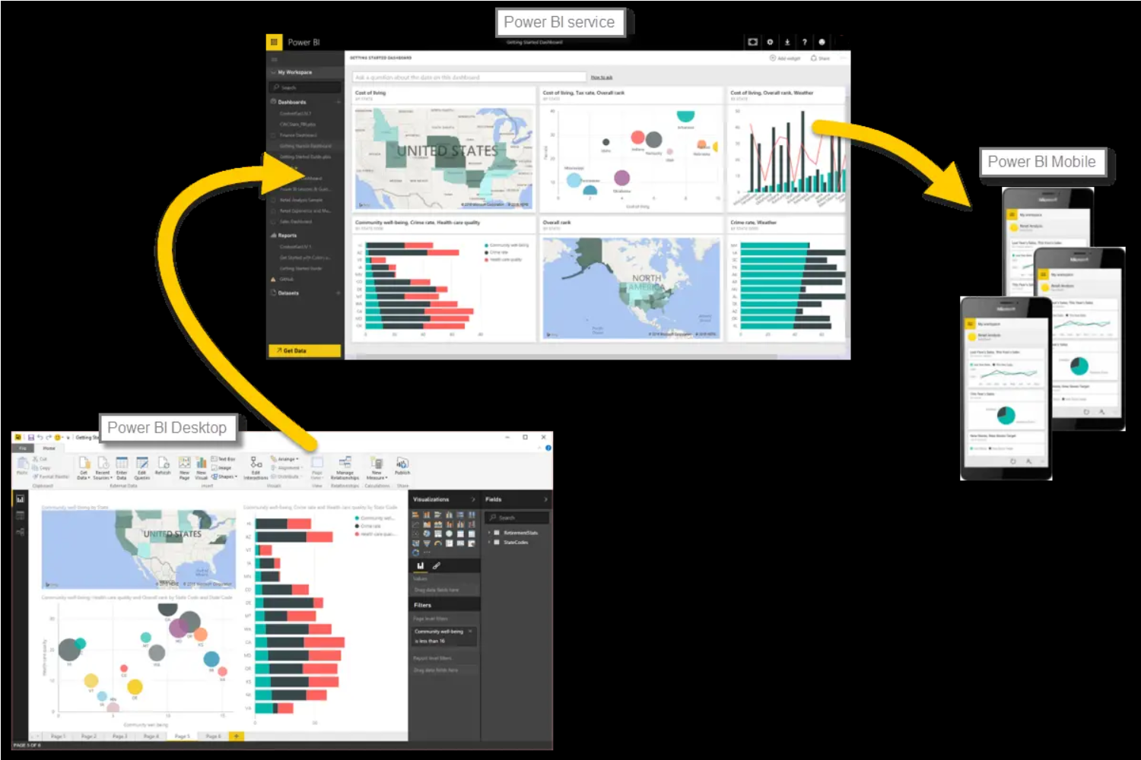

As mentioned earlier, you might spend all your time in the Power BI service, viewing visuals and reports that have been created by others. And that's fine. Someone else on your team might spend their time in Power BI Desktop, which is fine too. To help you understand the full continuum of Power BI and what it can do, we'll show you all of it. Then you can decide how to use it to your best advantage.

So, let's jump in and step through the experience. Your first order of business is to learn the basic building blocks of Power BI, which will provide a solid basis for turning data into cool reports and visuals.

### Building Blocks of Power BI

Everything you do in Microsoft Power BI can be broken down into a few basic building blocks. After you understand these building blocks, you can expand on each of them and begin creating elaborate and complex reports. After all, even seemingly complex things are built from basic building blocks. For example, buildings are created with wood, steel, concrete and glass, and cars are made from metal, fabric, and rubber. Of course, buildings and cars can also be basic or elaborate, depending on how those basic building blocks are arranged.

Let's take a look at these basic building blocks, discuss some simple things that can be built with them, and then get a glimpse into how complex things can also be created.

Here are the basic building blocks in Power BI:

* Visualizations
* Datasets
* Reports
* Dashboards
* Tiles

Visualizations

A visualization (sometimes also referred to as a visual) is a visual representation of data, like a chart, a color-coded map, or other interesting things you can create to represent your data visually. Power BI has all sorts of visualization types, and more are coming all the time. The following image shows a collection of different visualizations that were created in the Power BI service.

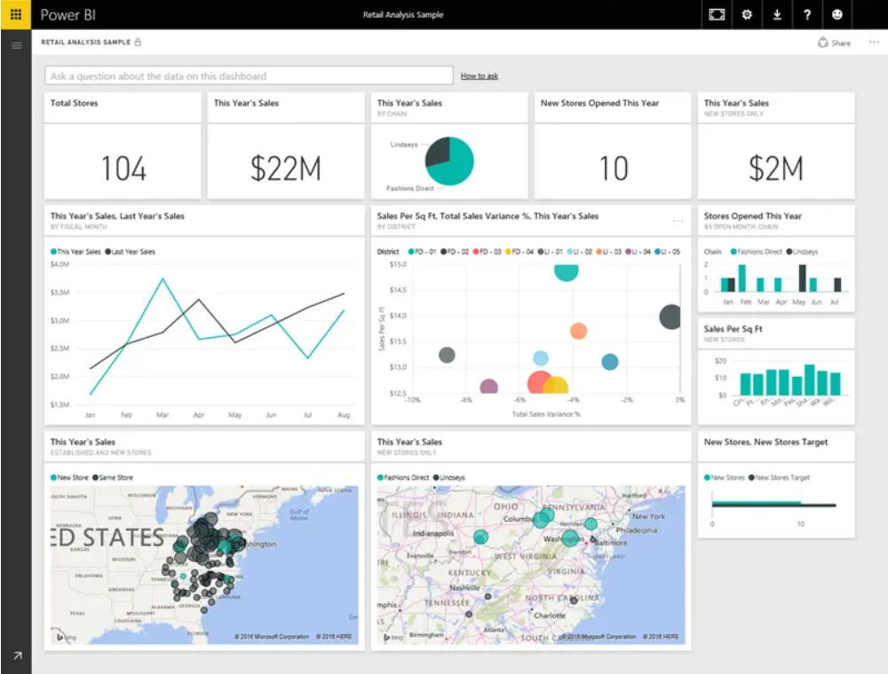

Visualizations can be simple, like a single number that represents something significant, or they can be visually complex, like a gradient-colored map that shows voter sentiment about a certain social issue or concern. The goal of a visual is to present data in a way that provides context and insights, both of which would probably be difficult to discern from a raw table of numbers or text.

#### Datasets

A **dataset** is a collection of data that Power BI uses to create its visualizations.

You can have a simple dataset that's based on a single table from a Microsoft Excel workbook, similar to what's shown in the following image.

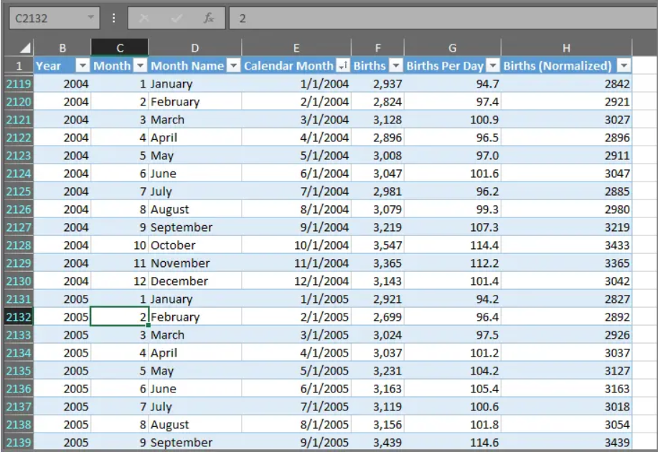

**Datasets** can also be a combination of many different sources, which you can filter and combine to provide a unique collection of data (a dataset) for use in Power BI.

For example, you can create a dataset from three database fields, one website table, an Excel table, and online results of an email marketing campaign. That unique combination is still considered a single **dataset**, even though it was pulled together from many different sources.

Filtering data before bringing it into Power BI lets you focus on the data that matters to you. For example, you can filter your contact database so that only customers who received emails from the marketing campaign are included in the dataset. You can then create visuals based on that subset (the filtered collection) of customers who were included in the campaign. Filtering helps you focus your data—and your efforts.

An important and enabling part of Power BI is the multitude of data connectors that are included. Whether the data you want is in Excel or a Microsoft SQL Server database, in Azure or Oracle, or in a service like Facebook, Salesforce, or MailChimp, Power BI has built-in data connectors that let you easily connect to that data, filter it if necessary, and bring it into your dataset.

After you have a dataset, you can begin creating visualizations that show different portions of it in different ways, and gain insights based on what you see. That's where reports come in.

#### Reports

In Power BI, a report is a collection of visualizations that appear together on one or more pages. Just like any other report you might create for a sales presentation or write for a school assignment, a report in Power BI is a collection of items that are related to each other. The following image shows a report in Power BI Desktop—in this case, it's the second page in a five-page report. You can also create reports in the Power BI service.

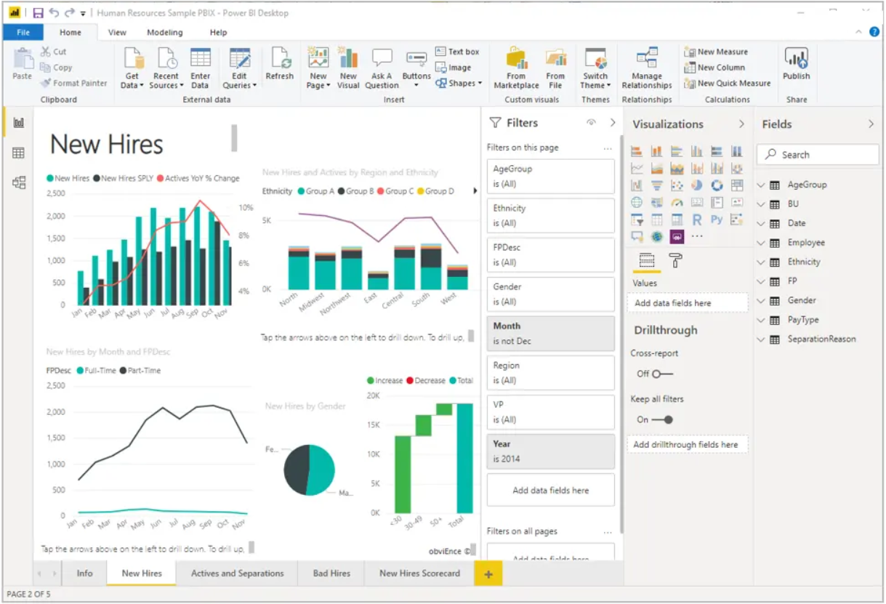

Reports let you create many visualizations, on multiple pages if necessary, and let you arrange those visualizations in whatever way best tells your story.

You might have a report about quarterly sales, product growth in a particular segment, or migration patterns of polar bears. Whatever your subject, reports let you gather and organize your visualizations onto one page (or more).

#### Dashboards

When you're ready to share a single page from a report, or a collection of visualizations, you create a dashboard. Much like the dashboard in a car, a Power BI dashboard is a collection of visuals from a single page that you can share with others. Often, it's a selected group of visuals that provide quick insight into the data or story you're trying to present.

A dashboard must fit on a single page, often called a canvas (the canvas is the blank backdrop in Power BI Desktop or the service, where you put visualizations). Think of it like the canvas that an artist or painter uses—a workspace where you create, combine, and rework interesting and compelling visuals. You can share dashboards with other users or groups, who can then interact with your dashboards when they're in the Power BI service or on their mobile device.

#### Tiles

In Power BI, a tile is a single visualization on a report or a dashboard. It's the rectangular box that holds an individual visual. In the following image, you see one tile, which is also surrounded by other tiles.

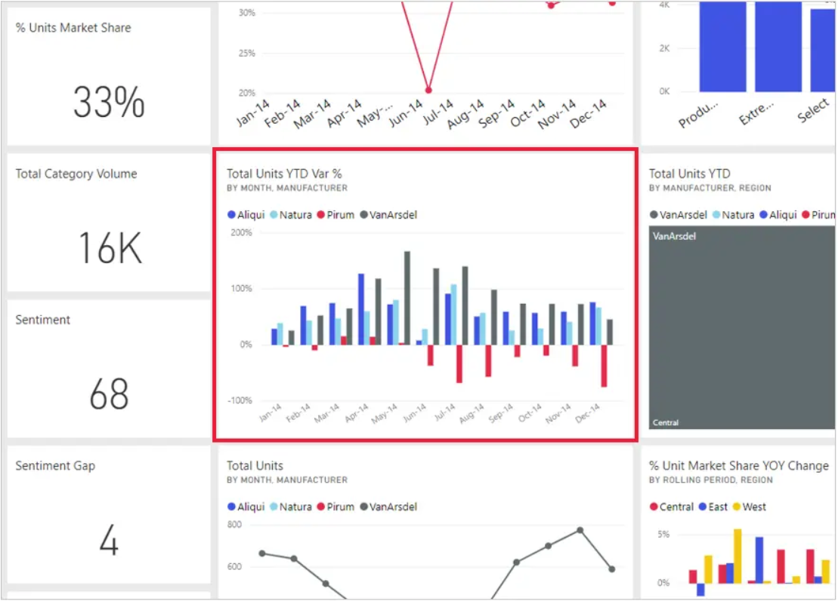

When you're creating a report or a dashboard in Power BI, you can move or arrange tiles however you want. You can make them bigger, change their height or width, and snuggle them up to other tiles.

When you're viewing, or consuming, a dashboard or report—which means you're not the creator or owner, but the report or dashboard has been shared with you—you can interact with it, but you can't change the size of the tiles or their arrangement.

#### All together now

Those are the basics of Power BI and its building blocks. Let's take a moment to review.

Power BI is a collection of services, apps, and connectors that lets you connect to your data, wherever it happens to reside, filter it if necessary, and then bring it into Power BI to create compelling visualizations that you can share with others.

Now that you've learned about the handful of basic building blocks of Power BI, it should be clear that you can create datasets that make sense to you and create visually compelling reports that tell your story. Stories told with Power BI don't have to be complex, or complicated, to be compelling.

For some people, using a single Excel table in a dataset and then sharing a dashboard with their team will be an incredibly valuable way to use Power BI.

For others, the value of Power BI will be in using real-time Azure SQL Data Warehouse tables that combine with other databases and real-time sources to build a moment-by-moment dataset.

For both groups, the process is the same: create datasets, build compelling visuals, and share them with others. And the result is also the same for both groups: harness your ever-expanding world of data, and turn it into actionable insights.

Whether your data insights require straightforward or complex datasets, Power BI helps you get started quickly and can expand with your needs to be as complex as your world of data requires. And because Power BI is a Microsoft product, you can count on it being robust, extensible, Microsoft Office–friendly, and enterprise-ready.

Now let's see how this works. We'll start by taking a quick look at the Power BI service.

### Exercise touring and using Power-BI

As we learned in the previous unit, the common flow of work in Microsoft Power BI is to create a report in Power BI Desktop, publish it to the Power BI service, and then share it with others, so that they can view it in the service or on a mobile app.

But because some people begin in the Power BI service, let's take a quick look at that first, and learn about an easy and popular way to quickly create visuals in Power BI: apps.

An app is a collection of preset, ready-made visuals and reports that are shared with an entire organization. Using an app is like microwaving a TV dinner or ordering a fast-food value meal: you just have to press a few buttons or make a few comments, and you're quickly served a collection of entrees designed to go together, all presented in a tidy, ready-to-consume package.

So, let's take a quick look at apps, the service, and how it works. We'll go into more detail about apps (and the service) in upcoming modules, but you can think of this as a taste to whet your appetite.

#### Create out-of-box dashboards with cloud services

With Power BI, connecting to data is easy. From the Power BI service, you can just select the Get Data button in the lower-left corner of the home page.

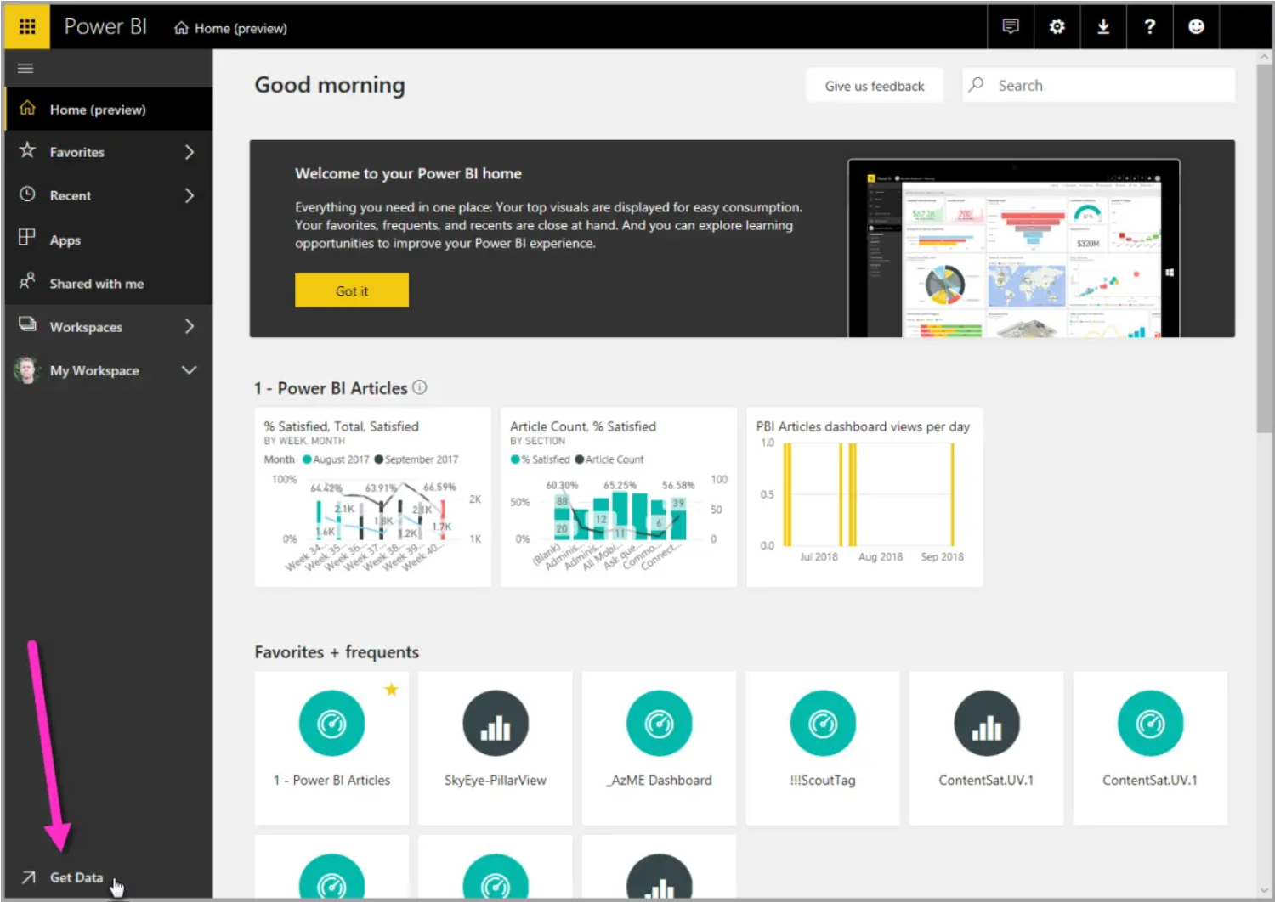

The canvas (the area in the center of the Power BI service) shows you the available sources of data in the Power BI service. In addition to common data sources like Microsoft Excel files, databases, or Microsoft Azure data, Power BI can just as easily connect to a whole assortment of software services (also called SaaS providers or cloud services): Salesforce, Facebook, Google Analytics, and more.

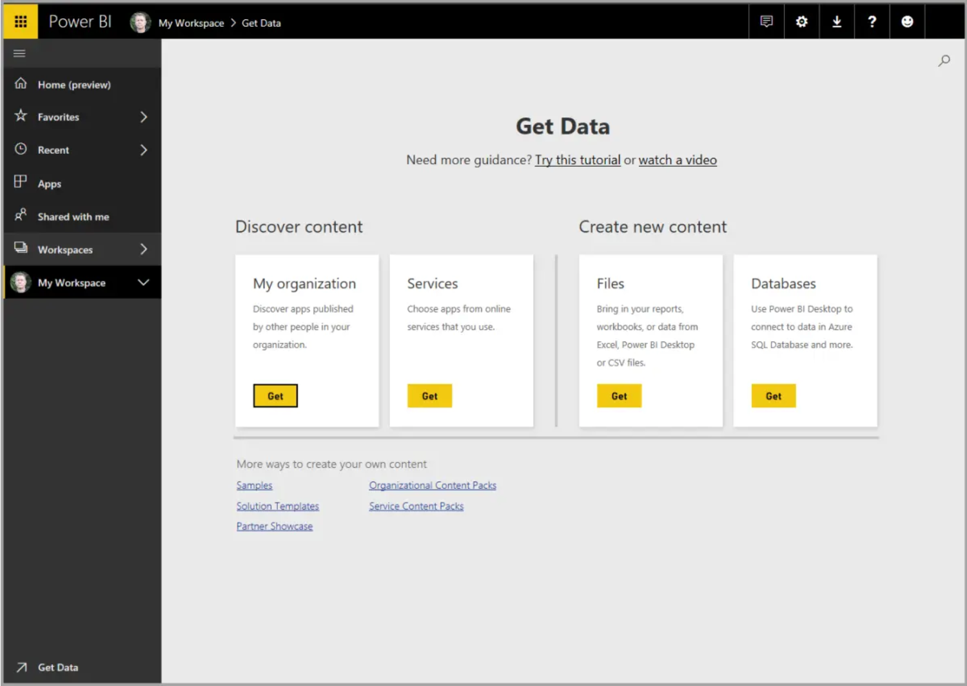

For these software services, the Power BI service provides a collection of ready-made visuals that are pre-arranged on dashboards and reports for your organization. This collection of visuals is called an app. Apps get you up and running quickly, with data and dashboards that your organization has created for you. For example, when you use the GitHub app, Power BI connects to your GitHub account (after you provide your credentials) and then populates a predefined collection of visuals and dashboards in Power BI.

There are apps for all sorts of online services. The following image shows a page of apps that are available for different online services, in alphabetical order. This page is shown when you select the Get button in the Services box (shown in the previous image). As you can see from the following image, there are many apps to choose from.

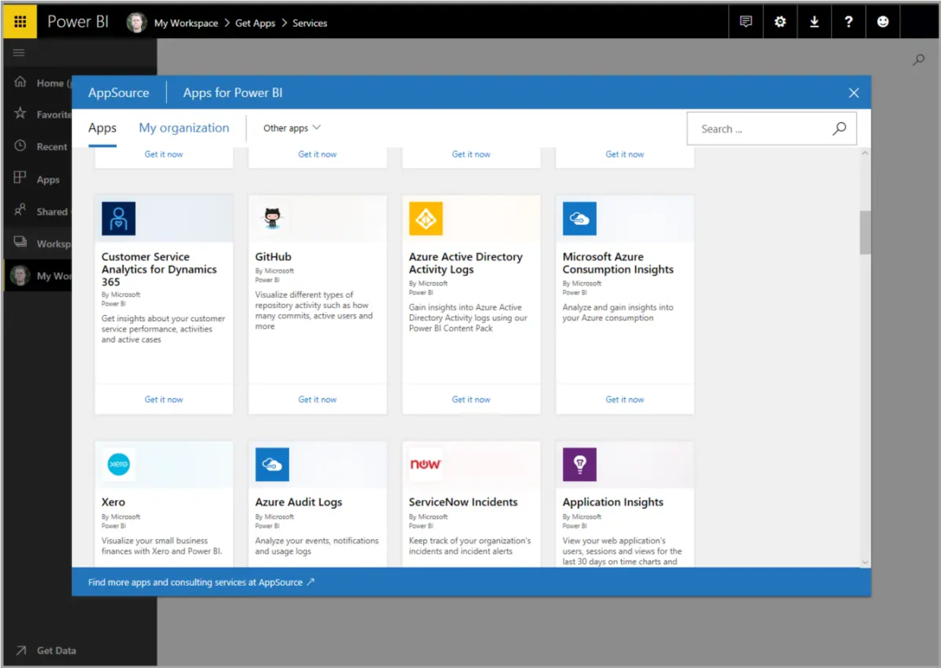

For our purposes, we'll choose GitHub. GitHub is an application for online source control. When you select the Get it now button in the box for the GitHub app, the Connect to GitHub dialog box appears. Note that Github does not support Internet Explorer, so make sure you are working in another browser.

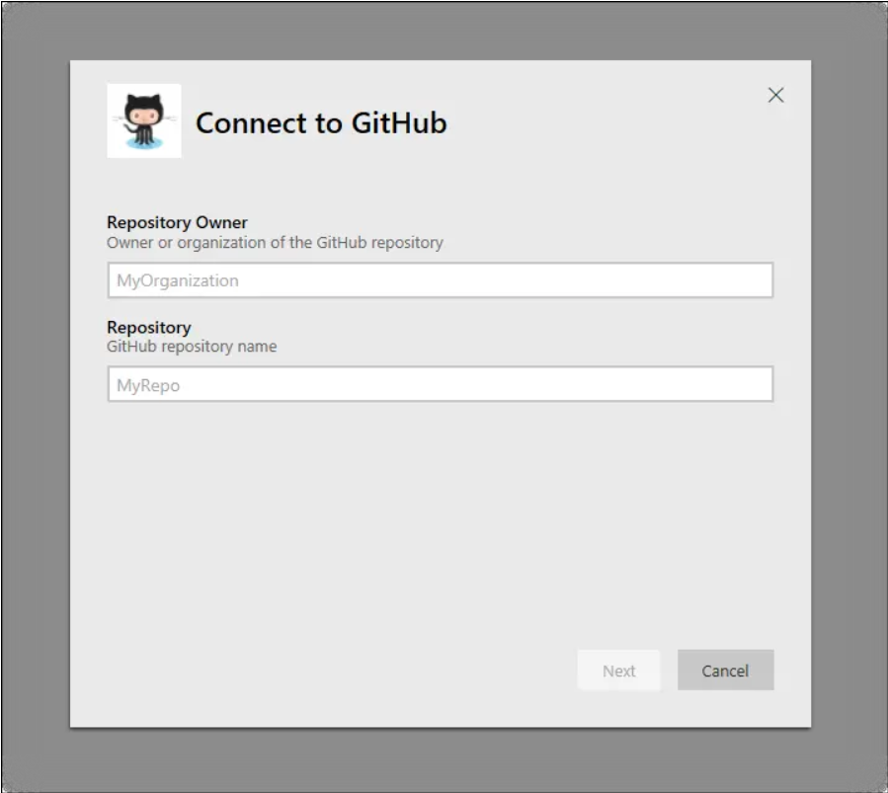

After you enter the information and credentials for the GitHub app, installation of the app begins.

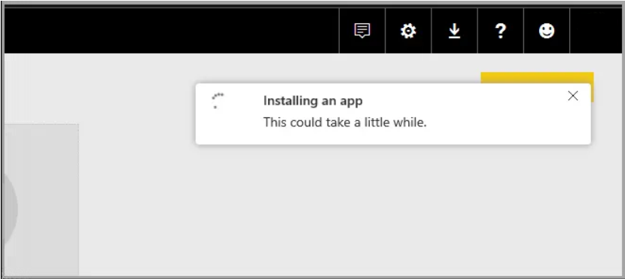

After the data is loaded, the predefined GitHub app dashboard appears.

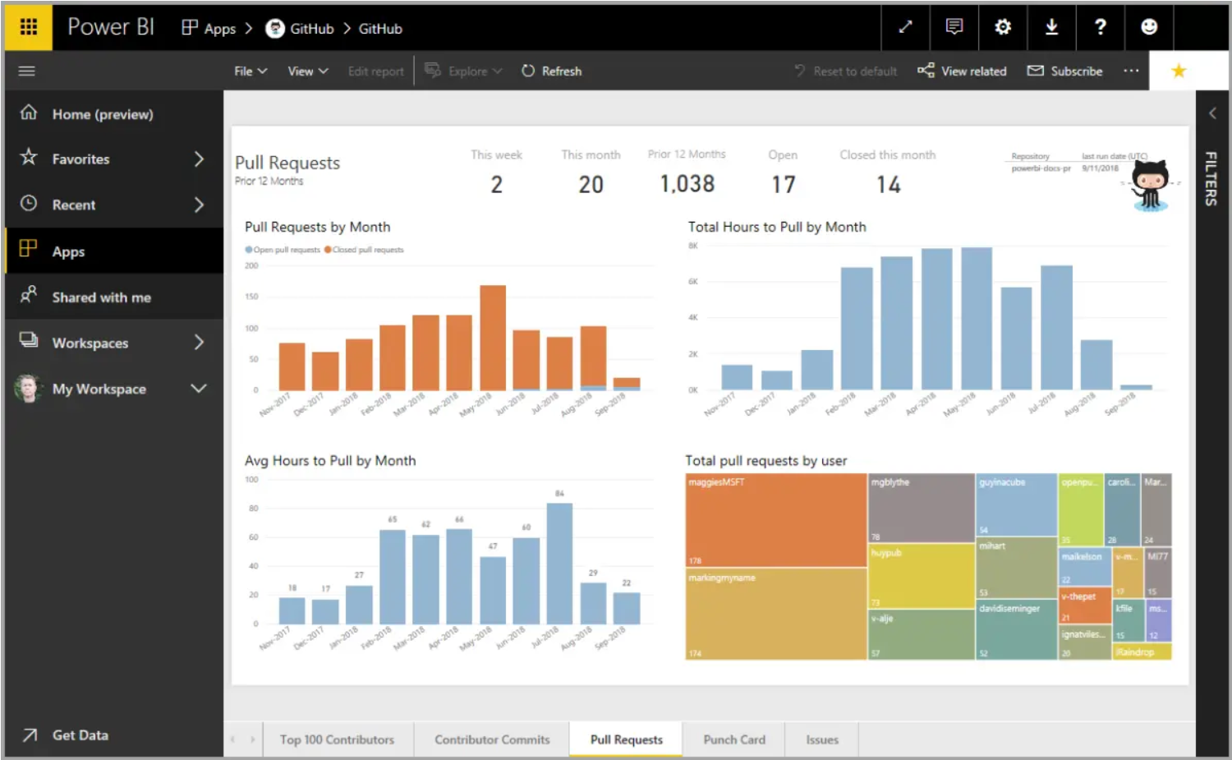

In addition to the app dashboard, the report that was generated (as part of the GitHub app) and used to create the dashboard is available, as is the dataset (the collection of data pulled from GitHub) that was created during data import and used to create the GitHub report.

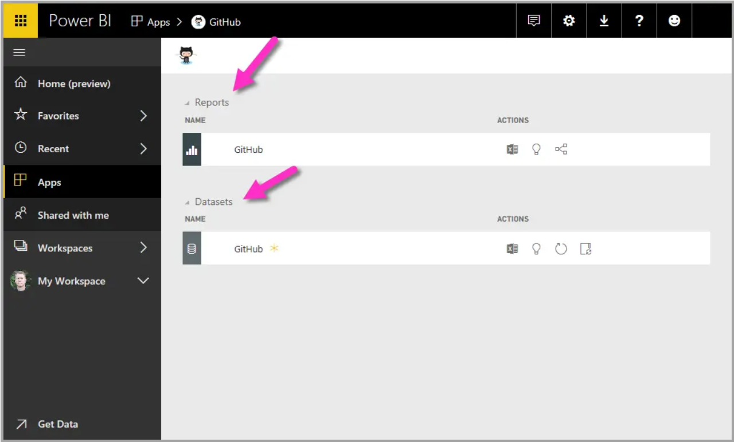

On the dashboard, you can select any of the visuals and interact with them. As you do so, all the other visuals on the page will respond. For example, when the May 2018 bar is selected in the Pull Requests (by month) visual, the other visuals on the page adjust to reflect that selection.

#### 

#### Update data in the Power BI service

You can also choose to update the dataset for an app, or other data that you use in Power BI. To set update settings, select the schedule update icon for the dataset to update, and then use the menu that appears. You can also select the update icon (the circle with an arrow) next to the schedule update icon to update the dataset immediately.

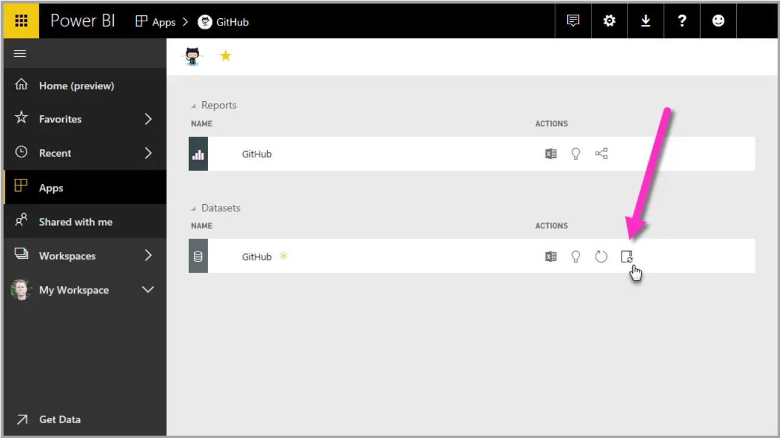

The Datasets tab is selected on the Settings page that appears. In the right pane, select the arrow next to Scheduled refresh to expand that section. The Settings dialog box appears on the canvas, letting you set the update settings that meet your needs.

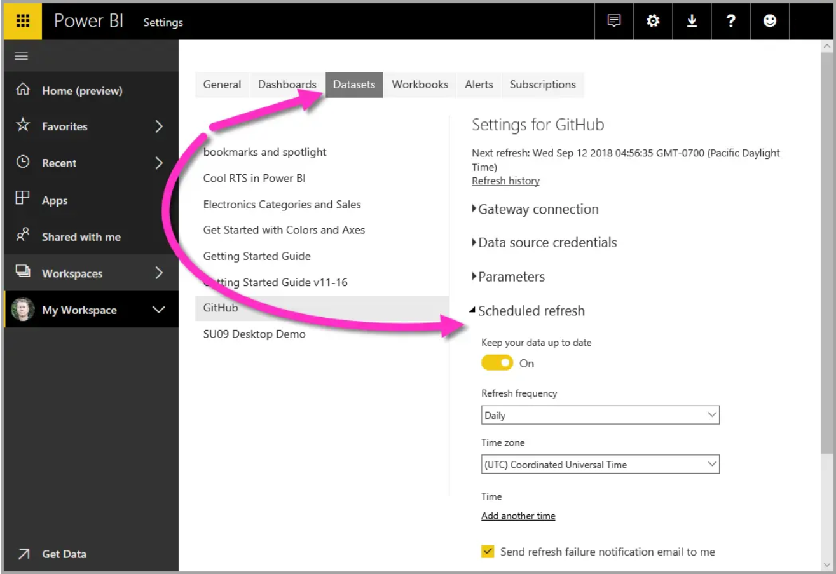

That's enough for our quick look at the Power BI service. There are many more things you can do with the service, and we'll cover these later in this module and in upcoming modules. Also, remember that there are many types of data you can connect to, and all sorts of apps, with more of both coming all the time.

### Lesson Review

Let's do a quick review of what we covered in this module.

Microsoft Power BI is a collection of software services, apps, and connectors that work together to turn your data into interactive insights. You can use data from single basic sources, like a Microsoft Excel workbook, or pull in data from multiple databases and cloud sources to create complex datasets and reports. Power BI can be as straightforward as you want or as enterprise-ready as your complex global business requires.

Power BI consists of three main elements—Power BI Desktop, the Power BI service, and Power BI Mobile—which work together to let you create, interact with, share, and consume your data the way you want.



We also discussed the basic building blocks in Power BI:

* Visualizations – A visual representation of data, sometimes just called visuals
* Datasets – A collection of data that Power BI uses to create visualizations
* Reports – A collection of visuals from a dataset, spanning one or more pages
* Dashboards – A single-page collection of visuals built from a report
* Tiles – A single visualization on a report or dashboard

In the Power BI service, we installed an app in just a few clicks. That app, a ready-made collection of visuals and reports, let us easily connect to a software service to populate the app and bring that data to life.

Finally, we set up a refresh schedule for our data, so that we know the data will be fresh when we go back to the Power BI service.

#### Next steps

Congratulations! You've finished the first module of the learning path for Power BI. You now have a firm foundation of knowledge for when you move on to the next module, which walks through the steps to create your first report.

We mentioned this before, but it's worth restating: this learning path builds your knowledge by following the common flow of work in Power BI:

* Bring data into Power BI Desktop, and create a report.
* Publish to the Power BI service, where you create new visualizations or build dashboards.
* Share your dashboards with others, especially people who are on the go.
* View and interact with shared dashboards and reports in Power BI Mobile apps.



You might not do all that work yourself—some people will only view dashboards that were created by someone else, and they'll just use the service. That's fine, and we'll soon have a module dedicated to showing how you can easily navigate and use the Power BI service to view and interact with reports and apps.

But the next module follows the flow of work in Power BI, showing you how to create a report and publish it to the Power BI service. You'll learn how those reports and dashboards are created and how they connected to the data. You might even decide to create a report or dashboard of your own.

See you in the next module!

### Knowledge Check

#### Question 1

What are the building blocks of Power BI?

* Tiles, dashboards, databases, mobile devices
* Visual Studio, C#, and JSON files
* Datasets, Visualizations, Reports, Dashboards, and Tiles

#### Question 2

What is the common flow of activity in Power BI?

* Bring data into Power BI Desktop and create a report, share it to the Power BI service, view and interact with reports and dashboards
* Bring data into Power BI mobile, create a report, then share it to Power BI Desktop.
* Create a report in the Power BI service, share it to Power BI mobile, interact with it in Power BI Desktop.
* Create a report in Power BI mobile, share it to the Power BI Desktop, view and interact in the Power BI service.

Question 3

A collection of ready-made visuals, pre-arranged in dashboards and reports is called what?

* The canvas
* An app
* A dataset
* Scheduled refresh

# Module 2 Get Data in Power BI

## Get Data from Various Data Sources

### Introduction to getting data

Like most of us, you work for a company where you are required to build Microsoft Power BI reports. The data resides in several different databases and files. These data repositories are different from each other, some are in Microsoft SQL Server, some are in Microsoft Excel, but all the data is related.

In this module's scenario you work for Tailwind Traders. You've been tasked by senior leadership to create a suite of reports that are dependent on data in several different locations. The database that tracks sales transactions is in SQL Server, a relational database contains which customer bought which items and when. It also tracks which employee made the sale, along with the employee name and employee ID. However, that database doesn't contain the employee's hire date, their title, or who their manager is. For that information, you need to access files that Human Resources keeps in Excel. You've been consistently requesting that they use an SQL database, but they haven't yet had the chance to implement it.

When an item ships, the shipment is recorded in the warehousing application, which is new to the company. The developers chose to store data in CosmosDB, as a set of JSON documents.

Tailwind Traders has an application that helps with financial projections, so that they can predict what their sales will be in future months and years, based on past trends. Those projections are stored in Microsoft Azure Analysis Services. Here's a view of the many data sources you are asked to combine data from.

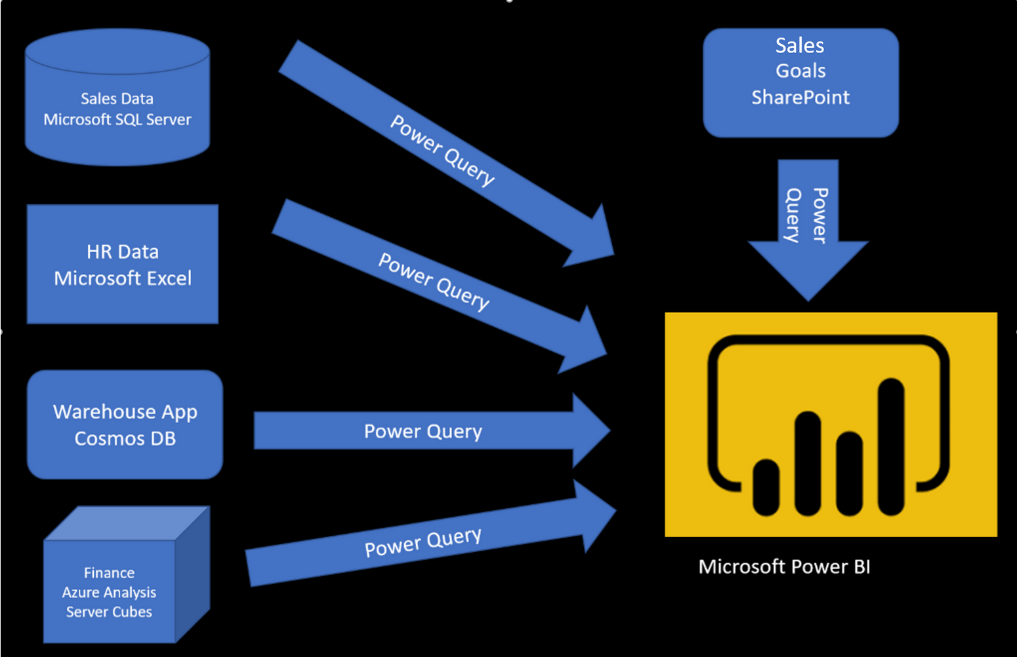

Before you can create reports, you must first extract data from the various data sources. Interacting with SQL Server is different from Excel, so you should learn the nuances of both systems. After you've learned the particulars of each system, you can use Power Query (the query engine used by Power BI and Excel) to help you clean the data, such as renaming columns, replacing values, removing errors, and combining query results. After the data has been cleaned and organized, you are ready to build reports in Power BI. Finally, you will publish your combined dataset and reports to Power BI service (PBIS). From there, other people can use your dataset and build their own reports or they can use the reports that you've already built. Additionally, if someone else built a dataset that you'd like to use, you can build reports from that, too!

This module will focus on the first step, of getting the data from the different data sources and importing it into Power BI by using Power Query.

* By the end of this module, you'll be able to:
* Identify and connect to a data source
* Get data from a relational database, such as Microsoft SQL Server
* Get data from a file, such as Microsoft Excel
* Get data from applications
* Get data from Azure Analysis Services
* Select a storage mode
* Fix performance issues
* Resolve data import errors

### Get data from flat files

Organizations often export and store data in files. One possible file format is a flat file. A flat file is a type of file that has only one data table and every row of data is in the same structure. The file does not contain hierarchies. Likely, you're familiar with the most common types of flat files, which are comma-separated values (.csv) files, delimited text (.txt) files, and fixed width files. Another type of file would be the output files from different applications, like Microsoft Excel workbooks (.xlsx).

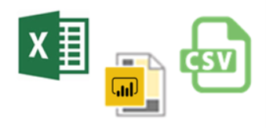

Power BI Desktop allows you to get data from many types of files. You can find a list of the available options when you use the Get data feature in Power BI Desktop. The following sections explain how you can import data from an Excel file that is stored on a local computer.

Scenario

The Human Resources (HR) team at Tailwind Traders has prepared a flat file that contains some of your organization's employee data, such as employee name, hire date, position, and manager. They've requested that you build Power BI reports by using this data, and data that is located in several other data sources.

### Flat file location

The first step is to determine which file location that you want to use to export and store your data.

Your Excel files might exist in one of the following locations:

* **Local** - You can import data from a local file into Power BI. The file isn't moved into Power BI, and a link doesn't remain to it. Instead, a new dataset is created in Power BI, and data from the Excel file is loaded into it. Accordingly, changes to the original Excel file are not reflected in your Power BI dataset. You can use local data import for data that doesn't change.
* **OneDrive for Business** - You can pull data from OneDrive for Business into Power BI. This method is effective in keeping an Excel file and your dataset, reports, and dashboards in Power BI synchronized. Power BI connects regularly to your file on OneDrive. If any changes are found, your dataset, reports, and dashboards are automatically updated in Power BI.
* **OneDrive - Personal** - You can use data from files on a personal OneDrive account, and get many of the same benefits that you would with OneDrive for Business. However, you'll need to sign in with your personal OneDrive account, and select the Keep me signed in option. Check with your system administrator to determine whether this type of connection is allowed in your organization.
* **SharePoint** - Team Sites - Saving your Power BI Desktop files to SharePoint Team Sites is similar to saving to OneDrive for Business. The main difference is how you connect to the file from Power BI. You can specify a URL or connect to the root folder.

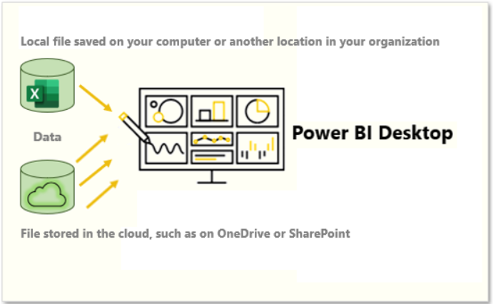

Using a cloud option such as OneDrive or SharePoint Team Sites is the most effective way to keep your file and your dataset, reports, and dashboards in Power BI in-sync. However, if your data does not change regularly, saving files on a local computer is a suitable option.

### Connect to data in a file

In Power BI, on the Home tab, select Get data. In the list that displays, select the option that you require, such as Text/CSV or XML. For this example, you will select Excel.

TIP: The Home tab contains quick access data source options, such as Excel, next to the Get data button, as seen in the image below.

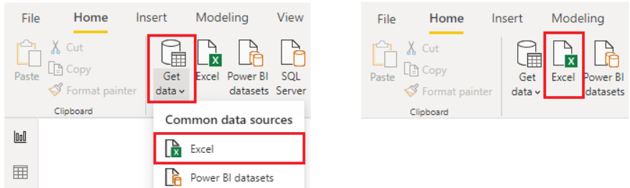

Depending on your selection, you need to find and open your data source. You might be prompted to sign into a service, such as OneDrive, to authenticate your request. In this example, you will open the Employee Data Excel workbook that is stored on the Desktop.

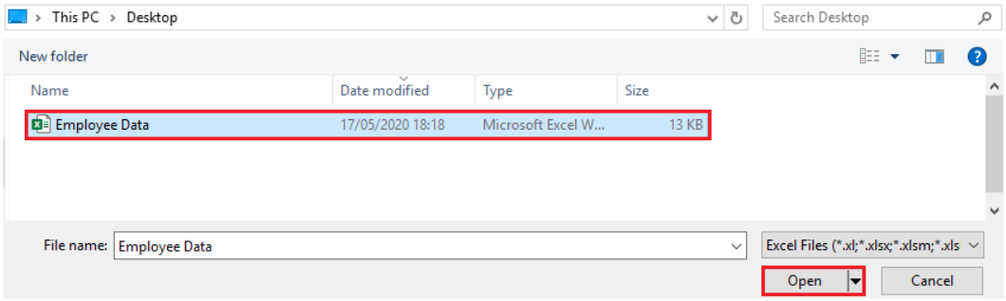

#### Select the file data to import

After the file has connected to Power BI Desktop, the Navigator window opens. This window shows you the data that is available in your data source (the Excel file in this example). You can select a table or entity to preview its contents, to ensure that the correct data is loaded into the Power BI model.

Select the check box(es) of the table(s) that you want to bring in to Power BI. This selection activates the Load and Transform Data buttons as shown in the following image.

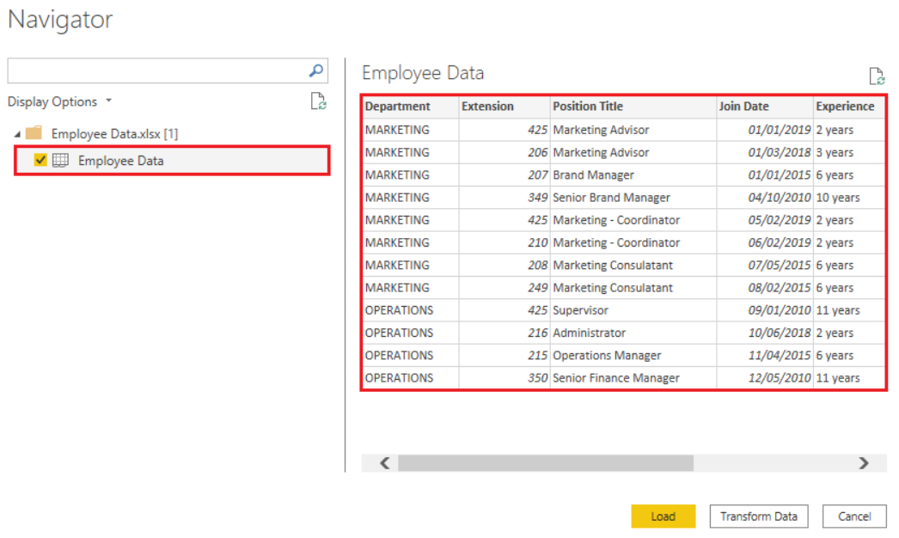

You now have the option to select the Load button to automatically load your data into the Power BI model or select the Transform Data button to launch the Power Query Editor, where you can review and clean your data before loading it into the Power BI model.

We often recommend that you transform data, but that process will be discussed later in this module. For this example, you can select Load.

#### Change the source file

You might have to change the location of a source file for a data source during development, or if a file storage location changes. To keep your reports up to date, you'll need to update your file connection paths in Power BI.

Power Query provides a number of ways for you to accomplish this task, so that you can make this type of change when needed.

* Data source settings
* Query settings
* Advanced Editor

**WARNING**: If you are changing a file path, make sure that you reconnect to the same file with the same file structure. Any structural changes to a file, such as deleting or renaming columns in the source file, will break the reporting model.

For example, try changing the data source file path in the data source settings. Select Data source settings in Power Query. In the Data source settings window, select your file and then select Change Source. Update the File path or use the Browse option to locate your file, select OK, and then select Close.

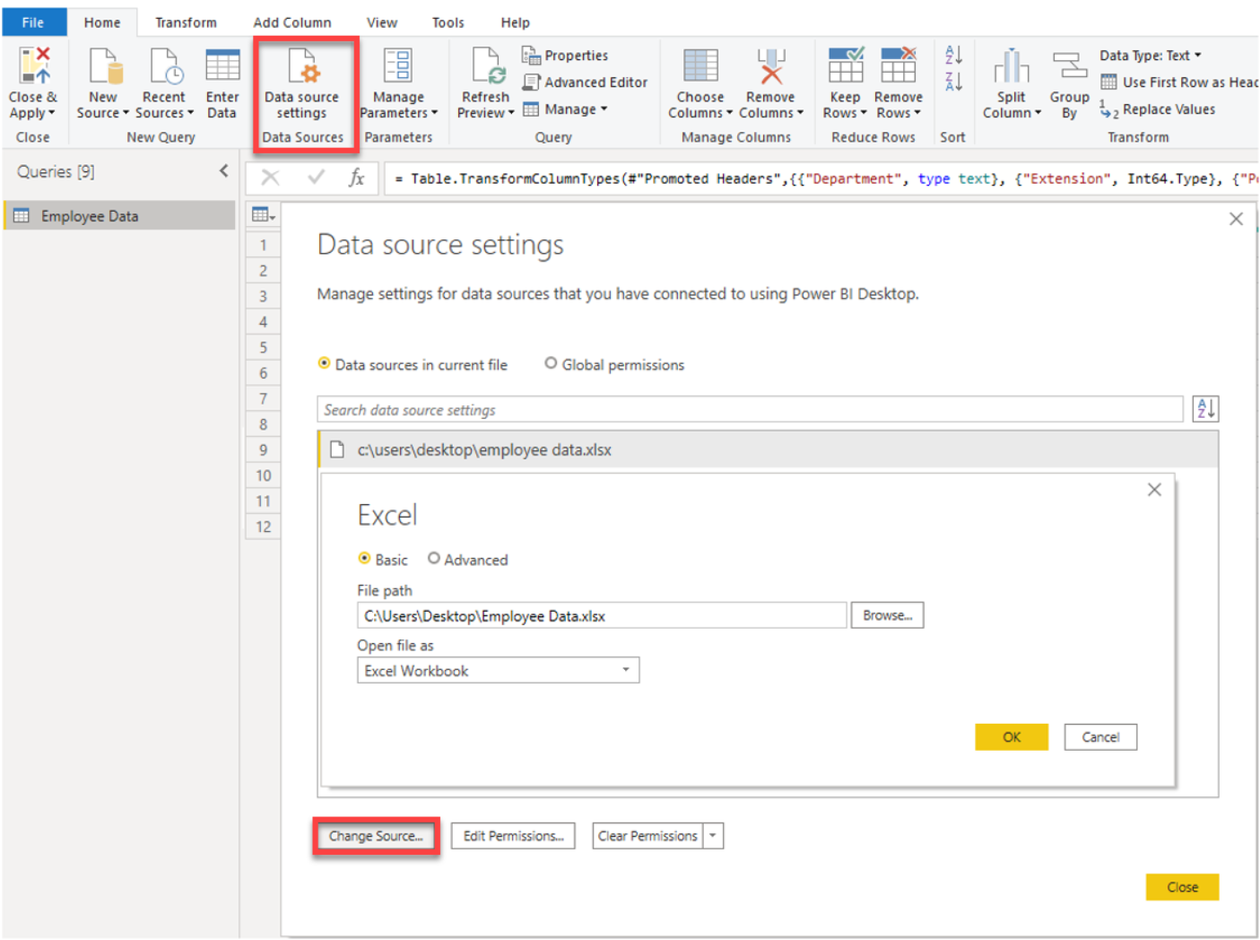

### Get data from relational data sources

If your organization uses a relational database to record its sales transactions, you can use Power BI Desktop to establish a connection to your organization's relational database, rather than getting data from individual flat files.

Connecting Power BI to your database will help you to monitor the progress of your business and identify trends, so you can forecast sales figures, plan budgets and set performance indicators and targets. Power BI Desktop can connect to many relational databases that are either in the cloud or on-premises.

**Scenario**

The Sales team at Tailwind Traders have requested that you connect to the organization's on-premises SQL Server database and get the sales data into Power BI Desktop so you can build sales reports.

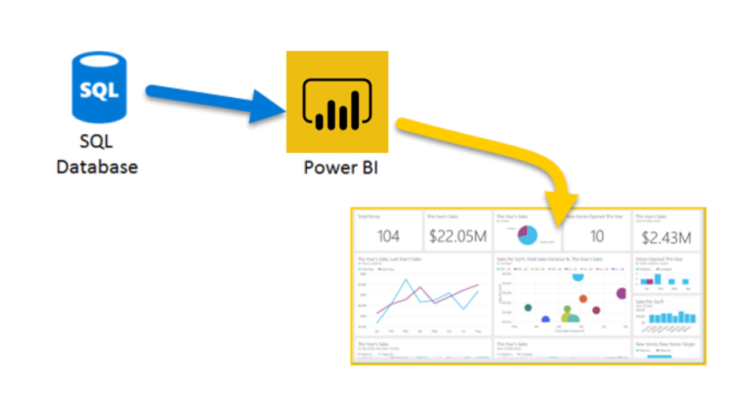

#### Connect to data in a relational database

You can use the Get data feature in Power BI Desktop and select the applicable option for your relational database. For this example, you would select the SQL Server option, as shown in the following screenshot.

TIP: Next to the Get Data button are quick access data source options, such as SQL Server.

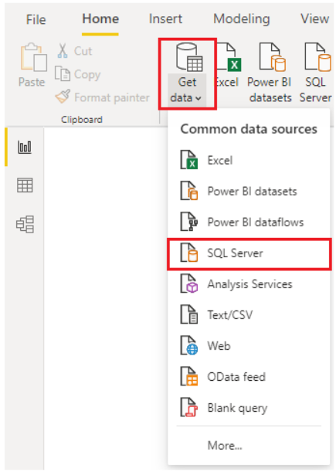

Your next step is to enter your database server name and a database name in the SQL Server database window. The two options in data connectivity mode are: Import (selected by default, recommended) and DirectQuery. Mostly, you select Import. Other advanced options are also available in the SQL Server database window, but you can ignore them for now.

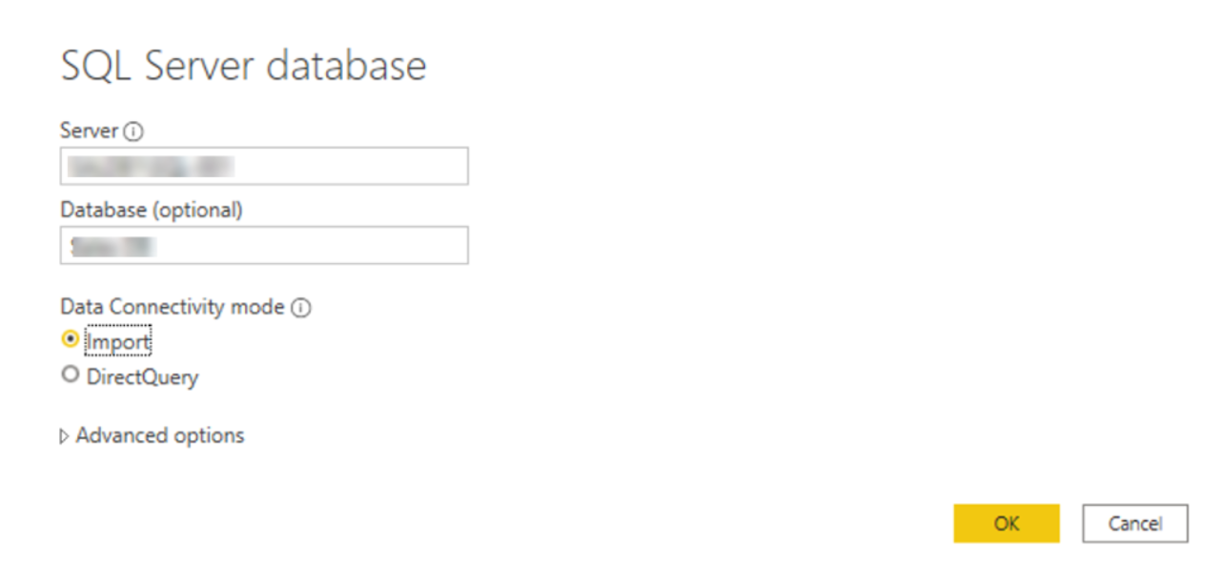

After you have added your server and database names, you will be prompted to sign in with a username and password. You will have three sign-in options:

* Windows - Use your Windows account (Azure Active Directory credentials).
* Database - Use your database credentials. For instance, SQL Server has its own sign-in and authentication system that is sometimes used. If the database administrator gave you a unique sign-in to the database, you might need to enter those credentials on the Database tab.
* Microsoft account - Use your Microsoft account credentials. This option is often used for Azure services.

Select a sign-in option, enter your username and password, and then select **Connect**.

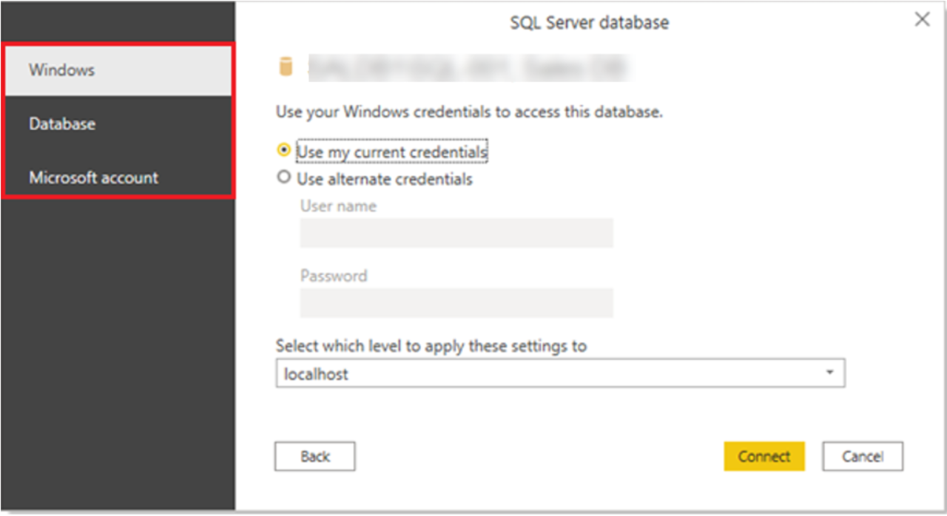

#### Select data to import

After the database has been connected to Power BI Desktop, the Navigator window displays the data that is available in your data source (the SQL database in this example). You can select a table or entity to preview its contents and make sure that the correct data will be loaded into the Power BI model.

Select the check box(es) of the table(s) that you want to bring in to Power BI Desktop, and then select either the Load or Transform Data option.

* Load - Automatically load your data into a Power BI model in its current state.
* Transform Data - Open your data in Microsoft Power Query, where you can perform actions such as deleting unnecessary rows or columns, grouping your data, removing errors, and many other data quality tasks.

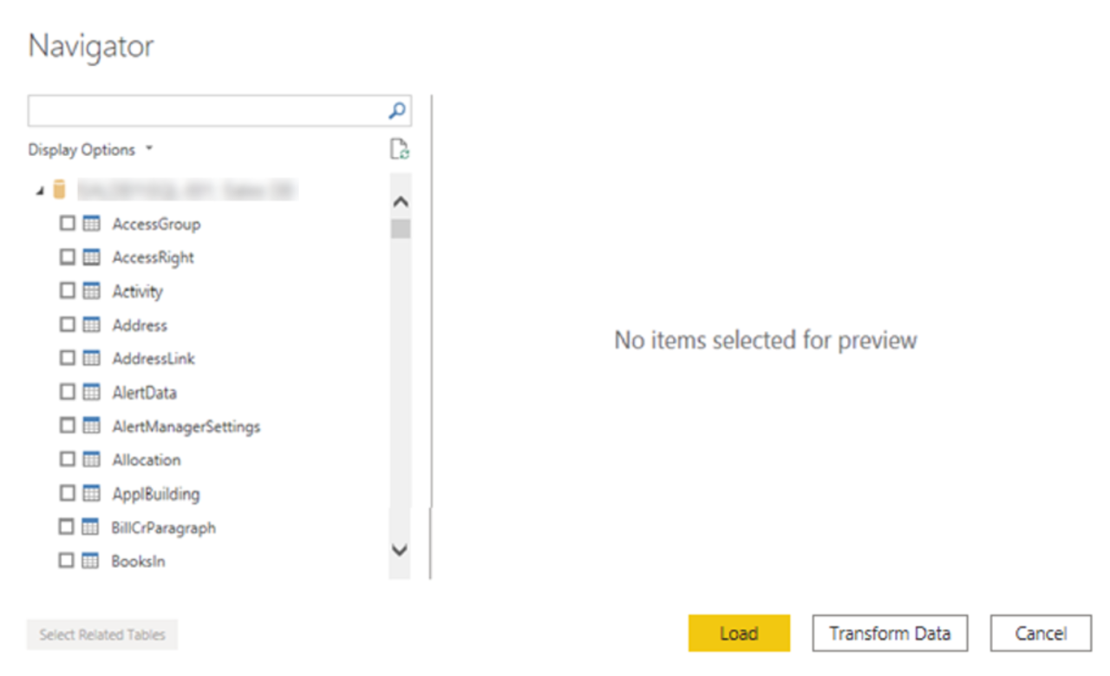

#### Import data by writing an SQL query

Another way you can import data is to write an SQL query to specify only the tables and columns that you need.

To write your SQL query, on the SQL Server database window, enter your server and database names, and then select the arrow next to Advanced options to expand this section and view your options. In the SQL statement box, write your query statement, and then select OK. In this example, you will use the Select SQL statement to load the ID, NAME and SALESAMOUNT columns from the SALES table.

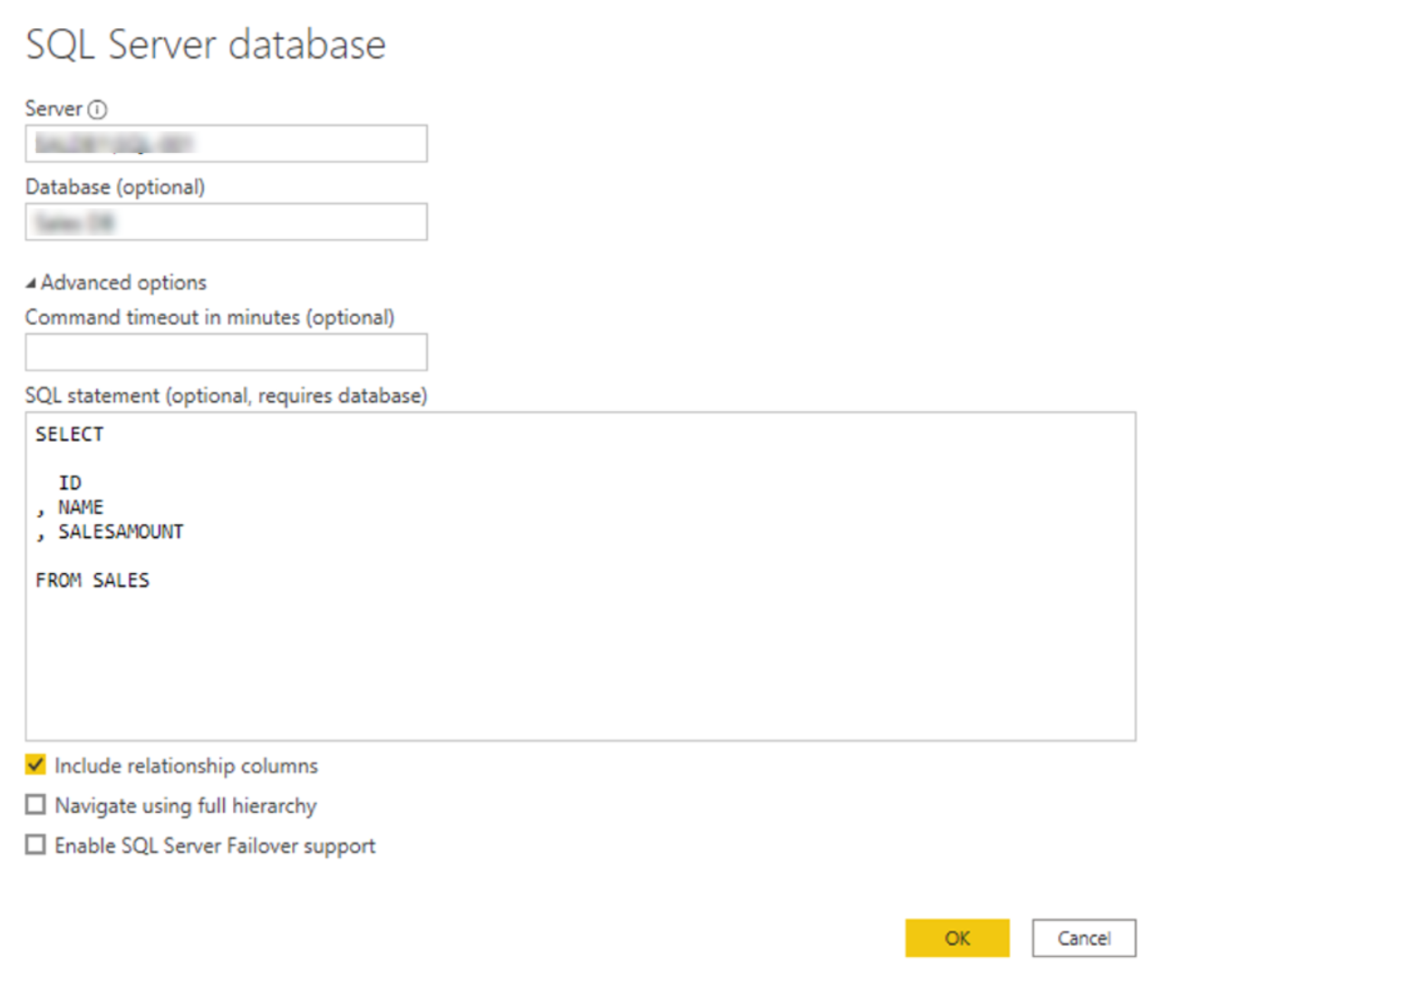

#### Change data source settings

After you create a data source connection and load data into Power BI Desktop, you can return and change your connection settings at any time. This action is often required due to a security policy within the organization, for example, when the password needs to be updated every 90 days. You can change the data source, edit permissions or clear permissions.

On the Home tab, select Transform data, and then select the Data source settings option.

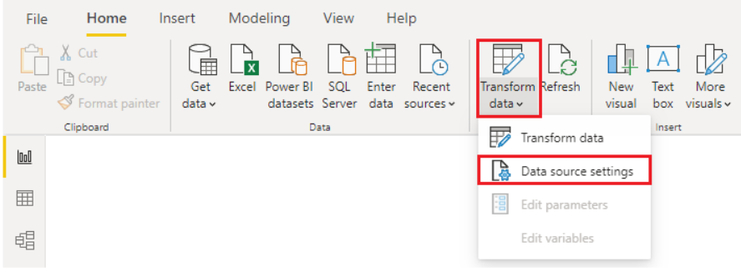

From the list of data sources that displays, select the data source that you want to update. Then, you can right-click that data source to view the available update options or you can use the update option buttons on the lower left of the window. Select the update option that you need, change the settings as required, and then apply your changes.

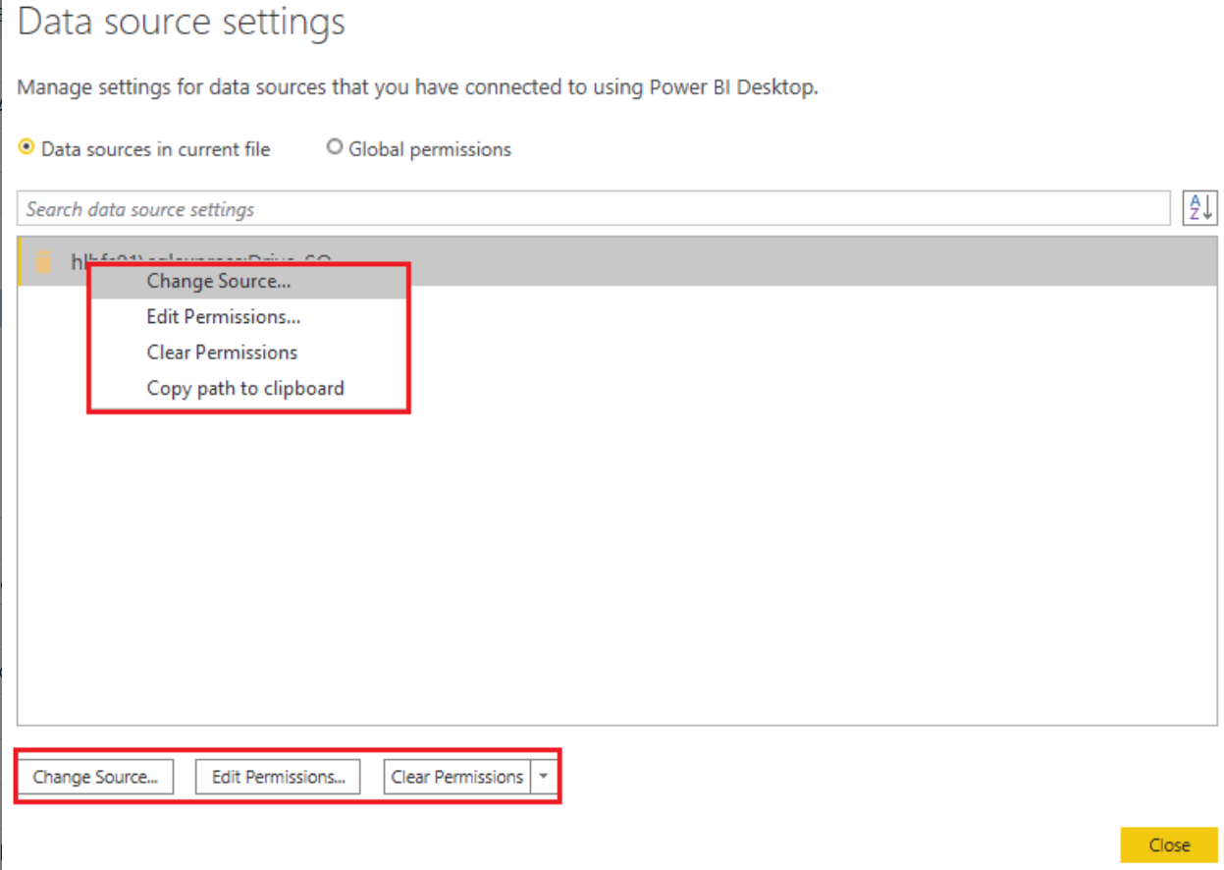

You can also change your data source settings from within Power Query. Select the table, and then select the Data source settings option on the Home ribbon. Alternatively, you can go to the Query Settings panel on the right side of the screen and select the settings icon next to Source (or double Select Source). In the window that displays, update the server and database details, and then select OK.

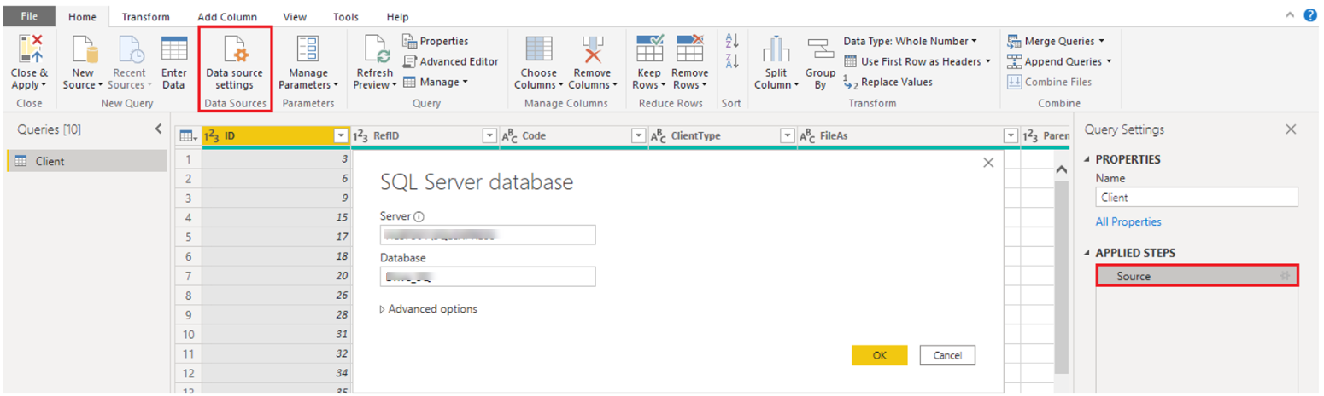

After you have made the changes, select Close and Apply to apply those changes to your data source settings.

#### Write an SQL statement

As previously mentioned, you can import data into your Power BI model by using an SQL query. SQL stands for Structured Query Language and is a standardized programming language that is used to manage relational databases and perform various data management operations.

Consider the scenario where your database has a large table that is comprised of sales data over several years. Sales data from 2009 is not relevant to the report that you are creating. This situation is where SQL is beneficial because it allows you to load only the required set of data by specifying exact columns and rows in your SQL statement and then importing them into your data model. You can also join different tables, run specific calculations, create logical statements, and filter data in your SQL query.

The following example shows a simple query where the ID, NAME and SALESAMOUNT are selected from the SALES table.

The SQL query starts with a Select statement, which allows you to choose the specific fields that you want to pull from your database. In this example, you want to load the ID, NAME, and SALESAMOUNT columns.

SELECT ID , NAME , SALESAMOUNT FROM

FROM specifies the name of the table that you want to pull the data from. In this case, it's the SALES table. The following example is the full SQL query:

SELECT ID , NAME , SALESAMOUNT FROM SALES

When using an SQL query to import data, try to avoid using the wildcard character (*) in your query. If you use the wildcard character (*) in your SELECT statement, you import all columns that you don't need from the specified table.

The following example shows the query using the wildcard character.

SELECT * FROM SALES

The wildcard character (*) will import all columns within the Sales table. This method is not recommended because it will lead to redundant data in your data model, which will cause performance issues and require additional steps to normalize your data for reporting.

All queries should also have a WHERE clause. This clause will filter the rows to pick only filtered records that you want. In this example, if you want to get recent sales data after Jan 1, 2020, add a WHERE clause. The evolved query would look like the following example.

SELECT ID , NAME , SALESAMOUNT FROM SALES WHERE OrderDate >= '1/1/2020'

It is a best practice to avoid doing this directly in Power BI. Instead, consider writing a query like this in a view. A view is an object in a relational database, similar to a table. Views have rows and columns, and can contain almost every operator in the SQL language. If Power BI uses a view, when it retrieves data, it participates in query folding, a feature of Power Query. Query folding will be explained later, but in short, Power Query will optimize data retrieval according to how the data is being used later.

### Get data from NoSQL

Some organization don't use a relational database but instead use a NoSQL database. A NoSQL database (also referred to as non-SQL, not only SQL or non-relational) is a flexible type of database that does not use tables to store data.

**Scenario**

Software developers at Tailwind Traders created an application to manage shipping and tracking products from their warehouses that uses CosmosDB, a NoSQL database, as the data repository. This application uses Cosmos DB to store JSON documents, which are open standard file formats that are primarily used to transmit data between a server and web application. You need to import this data into a Power BI data model for reporting.

#### Connect to a NoSQL database (Azure Cosmos DB)

In this scenario, you will use the Get data feature in Power BI Desktop. However, this time you will select the More… option to locate and connect to the type of database that you use. In this example, you will select the Azure category, select Azure Cosmos DB,and then select Connect.

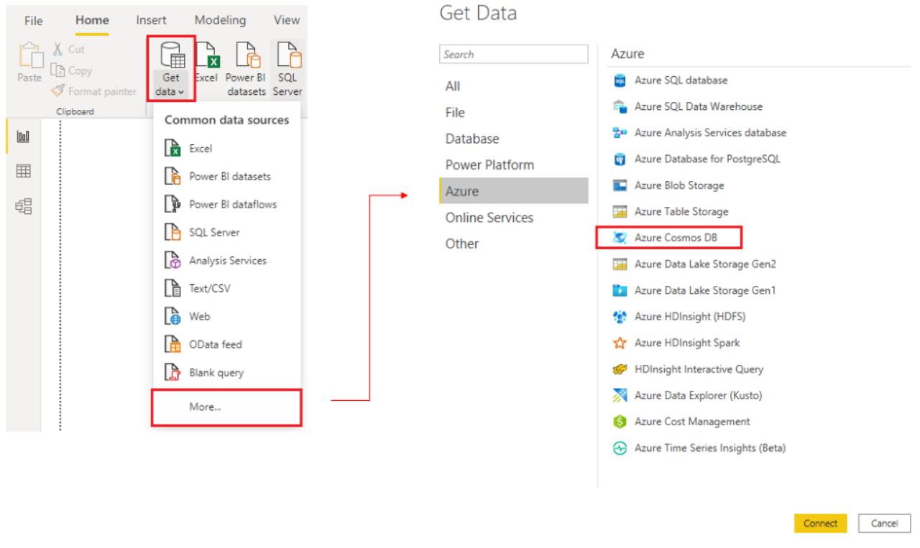

On the Preview Connector window, select Continue and then enter your database credentials. In this example, on the Azure Cosmos DB window, you can enter the database details. You can specify the Azure Cosmos DB account endpoint URL that you want to get the data from (you can get the URL from the Keys blade of your Azure portal). Alternatively, you can enter the database name, collection name or use the navigator to select the database and collection to identify the data source.

If you are connecting to an endpoint for the first time, as you are in this example, make sure that you enter your account key. You can find this key in the Primary Key box in the Read-only Keys blade of your Azure portal.

#### Import a JSON file

JSON type records must be extracted and normalized before you can report on them, so you need to transform the data before loading it into Power BI Desktop.

After you have connected to the database account, the Navigator window opens, showing a list of databases under that account. Select the table that you want to import. In this example, you will select the Product table. The preview pane only shows Record items because all records in the document are represented as a Record type in Power BI.

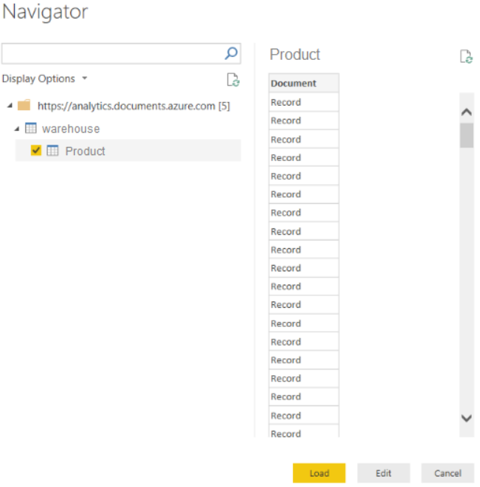

Select the Edit button to open the records in Power Query.

In Power Query, select the Expander button to the right side of the Column1 header, which will display the context menu with a list of fields. Select the fields that you want to load into Power BI Desktop, clear the Use original column name as prefix checkbox, and then select OK.

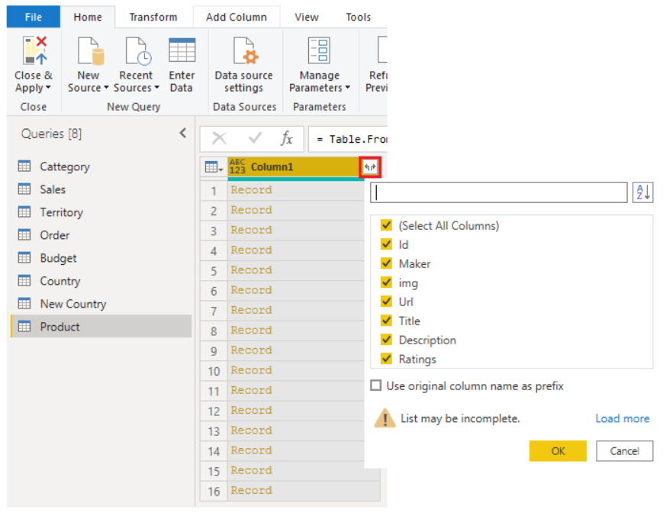

Review the selected data to ensure that you are satisfied with it, then select Close & Apply to load the data into Power BI Desktop.

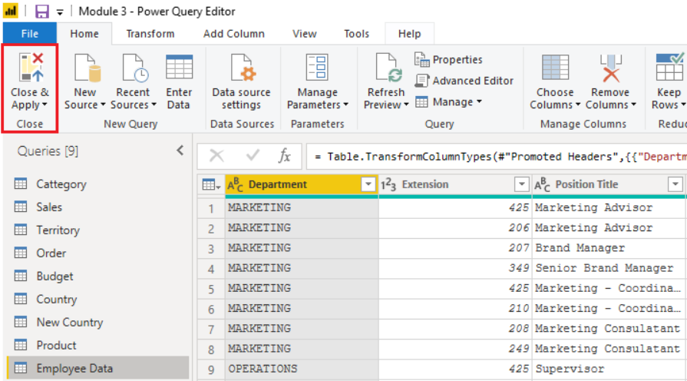

The data now resembles a table with rows and columns. Data from Cosmos DB can now be related to data from other data sources and can eventually be used in a Power BI report.

### Get data from applications

To support their daily operations, organizations frequently use a range of software applications, such as SharePoint, OneDrive, Dynamics 365, Google Analytics and so on. These applications produce their own data. Power BI can combine the data from multiple applications to produce more meaningful insights and reports.

**Scenario**:

Tailwind Traders uses SharePoint to collaborate and store sales data. It's the start of the new financial year and the sales managers want to enter new goals for the sales team. The form that the leadership uses exists in SharePoint. You are required to establish a connection to this data within Power BI Desktop, so that the sales goals can be used alongside other sales data to determine the health of the sales pipeline.

The following sections examine how to use the Power BI Desktop Get Data feature to connect to data sources that are produced by external applications. To illustrate this process, an example is provided that shows how to connect to a SharePoint site and import data from an online list.

#### Connect to data in an application

When connecting to data in an application, you would begin in the same way as you would when connecting to the other data sources: by selecting the Get data feature in Power BI Desktop. Then, select the option that you need from the Online Services category. In this example, you select SharePoint Online List.

After you have selected Connect, you'll be asked for your SharePoint URL. This URL is the one that you use to sign into your SharePoint site through a web browser. You can copy the URL from your SharePoint site and paste it into the connection window in Power BI. You do not need to enter your full URL file path; you only need to load your site URL because, when you are connected, you can select the specific list that you want to load. Depending on the URL that you copied, you might need to delete the last part of your URL, as illustrated in the following image.

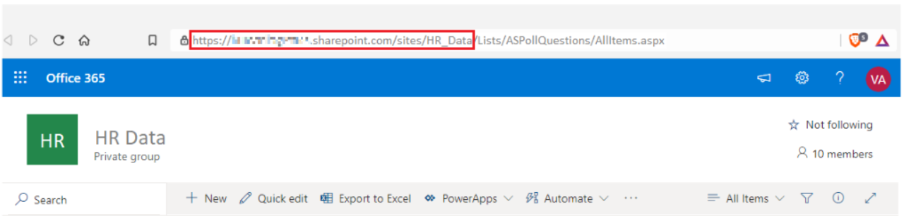

After you have entered your URL, select OK. Power BI needs to authorize the connection to SharePoint, so sign in with your Microsoft account and then select Connect.

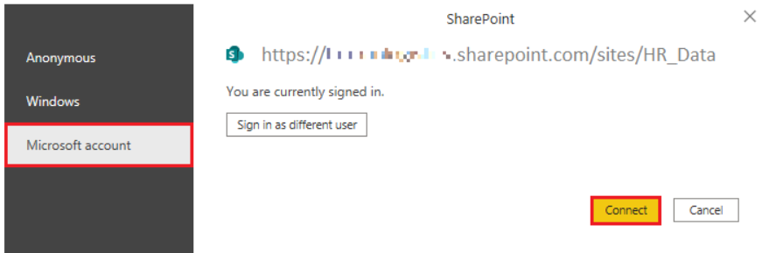

#### Choose the application data to import

After Power BI has made the connection with SharePoint, the Navigator window appears, as it does when you connect to other data sources. The window displays the tables and entities within your SharePoint site. Select the list that you want to load into Power BI Desktop. Similar to when you import from other data sources, you have the option to automatically load your data into Power BI model or launch the Power Query Editor to transform your data before loading it.

For this example, you select the **Load** option.

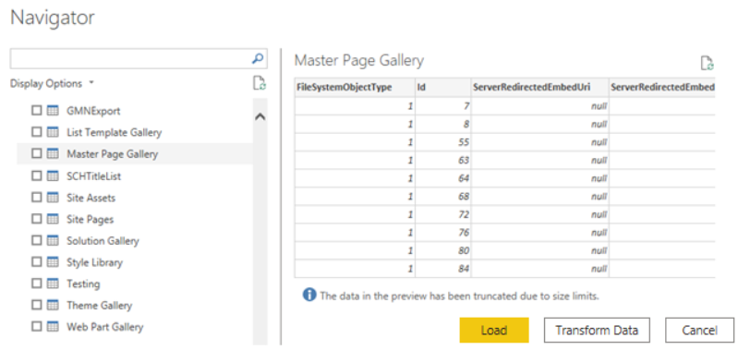

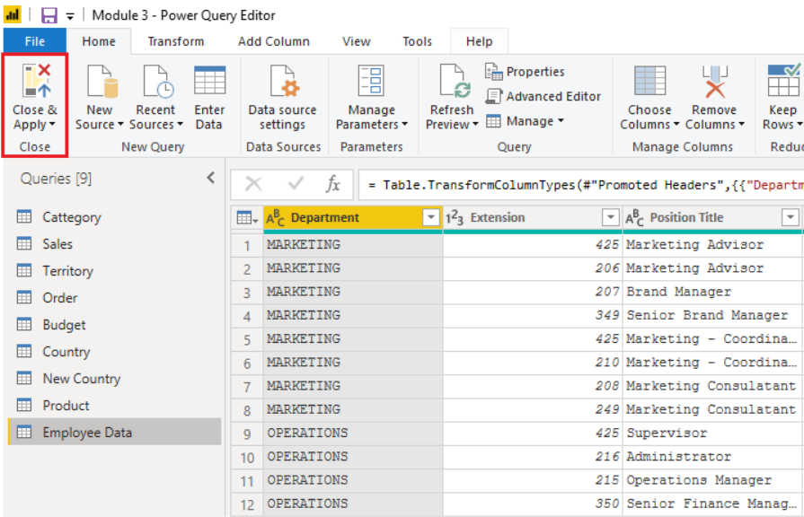

When you are satisfied with your data, select the Close & Apply button to apply your changes and load your data into Power BI Desktop.

### Get data from Analysis Services

Azure Analysis Services is an Azure product that allows you to ingest data from multiple data sources, build relationships between the data, and creates calculations on the data. The calculations are built using data analysis expressions (DAX). Azure Analysis Services is similar to the data modeling and storage technology in Power BI.

To resume the scenario, Tailwind Traders uses Azure Analysis Services to store financial projection data. You've been asked to compare this data with actual sales data in a different database. Getting data from Azure Analysis Services cubes is similar to getting data from SQL Server, in that you can:

* Authenticate to the server.
* Pick the cube you want to use.
* Select which tables you need.

Notable differences between Azure Analysis Services cubes and SQL Server are:

* Analysis Services cubes have calculations already in the cube, which will be discussed in more detail later.
* If you don't need an entire table, you can query the data directly. Instead of using Transact-SQL (T-SQL) to query the data, like you would in SQL Server, you can use multi-dimensional expressions (MDX) or data analysis expressions (DAX).
* You don't need to use the Get Data button in Power BI Desktop.

#### Connect to data in Azure Analysis Services

As previously mentioned, you use the Get data feature in Power BI Desktop. When you select Analysis Services, you are prompted for the server address and the database name with two options: Import and Connect live.

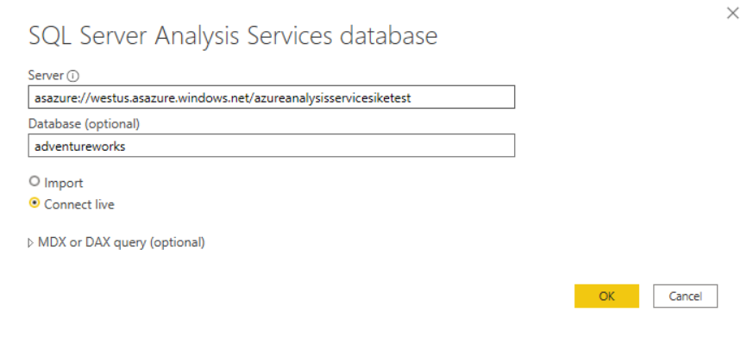

**Connect live** is a new option in Azure Analysis Services. Azure Analysis Services uses the tabular model and DAX to build calculations, similar to Power BI. These models are compatible with one another. Using the Connect live option helps you keep the data and DAX calculations in their original location, without having to import them all into Power BI. Azure Analysis Services can have a fast refresh schedule , which means that when data is refreshed in the service, Power BI reports will immediately be updated, without the need to initiate a Power BI refresh schedule. This process can improve the timeliness of the data in your report.

Similar to a relational database, you can choose the tables that you want to use. If you want to directly query the Azure Analysis Services model, you can use DAX or MDX.

Because you want to get data to other data in your organization , you will likely import the data directly into Power BI. An acceptable alternative is to import all other data that you want (from Excel, SQL Server, and so on) into the Azure Analysis Services model and then use a live connection. Using this approach, the data modeling and DAX measures are all performed in one place, and it's a much simpler and easier way to maintain your solution.

For more information on connecting Power BI to Azure Analysis Services, please refer to [Connect with Power BI documentation](https://docs.microsoft.com/en-ca/azure/analysis-services/analysis-services-connect-pbi).

### Knowledge Check

#### Question 1

Which query language do you use to extract data from Microsoft SQL Server?

* DAX
* T-SQL
* MDX

#### Question 2

You’re creating a Power BI report with data from an Azure Analysis Services Cube. When the data refreshes in the cube, you would like to see it immediately in the Power BI report. How should you connect?

* Connect Live
* Import
* Direct Query

#### Question 3

What can you do to improve performance when you are getting data in Power BI?

* Only pull data into the Power BI service, not Power BI Desktop
* Use the Select SQL statement in your SQL queries when you are pulling data from a relational database
* Combine date and time columns into a single column
* Do some calculations in the original data source

## Optimize Performance

### Select a storage mode

The most popular way to use data in Power BI is to import it into a Power BI dataset. Importing the data means that the data is stored in the Power BI file and gets published along with the Power BI reports. This process helps make it easier for you to interact directly with your data. However, this approach might not work for all organizations.

To continue with the scenario, you are building Power BI reports for the Sales department at Tailwind Traders, where importing the data is not an ideal method. The first task you need to accomplish is to create your datasets in Power BI so you can build visuals and other report elements. The Sales department has many different datasets of varying sizes. For security reasons, you are not allowed to import local copies of the data into your reports, so directly importing data is no longer an option. Therefore, you need to create a direct connection to the Sales department's data source. The following section describes how you can ensure that these business requirements are satisfied when you are importing data into Power BI.

However, sometimes there may be security requirements around your data that make it impossible to directly import a copy. Or your datasets may simply be too large and would take too long to load into Power BI, and you want to avoid creating a performance bottleneck. Power BI solves these problems by using the DirectQuery storage mode, which allows you to query the data in the data source directly and not import a copy into Power BI. DirectQuery is useful because it ensures you are always viewing the most recent version of the data.

The three different types of storage modes you can choose from:

* Import
* DirectQuery
* Dual (Composite)

You can access storage modes by switching to the Model view, selecting a data table, and in the resulting Properties pane, selecting which mode that you want to use from the Storage mode drop-down list, as shown in the following visual.

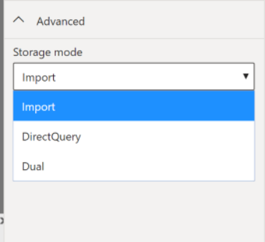

Let's take a closer look at the different types of Storage Modes.

#### Import mode

The Import mode allows you to create a local Power BI copy of your datasets from your data source. You can use all Power BI service features with this storage mode, including Q&A and Quick Insights. However, data refreshes must be done manually. Import mode is the default for creating new Power BI reports.

#### DirectQuery mode

The DirectQuery option is useful when you do not want to save local copies of your data because your data will not be cached. Instead, you can query the specific tables that you will need by using native Power BI queries, and the required data will be retrieved from the underlying data source. Essentially, you are creating a direct connection to the data source. Using this model ensures that you are always viewing the most up-to-date data, and that all security requirements are satisfied. Additionally, this mode is suited for when you have large datasets to pull data from. Instead of slowing down performance by having to load large amounts of data into Power BI, you can use DirectQuery to create a connection to the source, solving data latency issues as well.

#### Dual (Composite mode)

In Dual mode, you can identify some data to be directly imported and other data that must be queried. Any table that is brought in to your report is a product of both Import and DirectQuery modes. Using the Dual mode allows Power BI to choose the most efficient form of data retrieval.

For more information regarding Storage Modes, please refer to [Storage Modes](https://docs.microsoft.com/en-ca/power-bi/transform-model/desktop-storage-mode).

### Fix performance issues

Occasionally, organizations will need to address performance issues when running reports. Power BI provides the Performance Analyzer tool to help fix problems and streamline the process.

Consider the scenario where you are building reports for the Sales team in your organization. You've imported your data, which is in several tables within the Sales team's SQL database, by creating a data connection to the database through DirectQuery. When you create preliminary visuals and filters, you notice that some tables are queried faster than others, and some filters are taking longer to process compared to others.

#### Query diagnostics

Another tool that you can use to study query performance is query diagnostics. This feature allows you to determine what bottlenecks (if any) exist while loading and transforming your data, refreshing your data in Power Query, running SQL statements in Query Editor, and so on.

To access query diagnostics in Power Query Editor, go to Tools in the Home ribbon. When you are ready to begin transforming your data or making other edits in Power Query Editor, select Start Diagnostics on the Session Diagnostics tab. When you are finished, make sure that you select Stop **Diagnostics**.

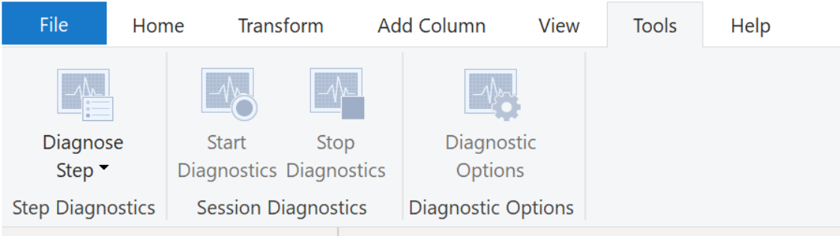

Selecting Diagnose Step shows you the length of time that it takes to run that step, as shown in the following image. This selection can tell you if a step takes longer to complete than others, which then serves as a starting point for further investigation.



This tool is useful when you want to analyze performance on the Power Query side for tasks such as loading datasets, running data refreshes, or running other transformative tasks.

#### Other techniques to optimize performance

Other ways to optimize query performance in Power BI include:

* Process as much data as possible in the original data source. Power Query and Power Query Editor allow you to process the data; however, the processing power that is required to complete this task might lower performance in other areas of your reports. Generally, a good practice is to process, as much as possible, in the native data source.
* Use native SQL queries. When using DirectQuery for SQL databases, such as the case for our scenario, make sure that you are not pulling data from stored procedures or common table expressions (CTEs).
* Separate date and time, if bound together. If any of your tables have columns that combine date and time, make sure that you separate them into distinct columns before importing them into Power BI. This approach will increase compression abilities.

For more information, refer to [Query Folding Guidance](https://docs.microsoft.com/en-ca/power-bi/guidance/power-query-folding) and [Query Folding](https://docs.microsoft.com/en-ca/power-query/power-query-folding).

### Optimize performance in Power Query

The performance in Power Query depends on the performance at the data source level. The variety of data sources that Power Query offers is very wide, and the performance tuning techniques for each source are equally wide. For instance, if you extract data from a Microsoft SQL Server, you should follow the performance tuning guidelines for the product. Good SQL Server performance tuning techniques includes index creation, hardware upgrades, execution plan tuning, and data compression. These topics are beyond the scope here, and are covered only as an example to build familiarity with your data source and reap the benefits when using Power BI and Power Query.

Power Query takes advantage of good performance at the data source through a technique called Query Folding.

### Query folding

The query folding within Power Query Editor helps you increase the performance of your Power BI reports. Query folding is the process by which the transformations and edits that you make in Power Query Editor are simultaneously tracked as native queries, or simple Select SQL statements, while you are actively making transformations. The reason for implementing this process is to ensure that these transformations can take place in the original data source server and do not overwhelm Power BI computing resources.

You can use Power Query to load data into Power BI. Using Power Query Editor you can then make further transformations to your data, such as renaming or deleting columns, appending, parsing, filtering, or grouping your data.

Consider a scenario where you've renamed a few columns in the Sales data and merged a city and state column together in the “city state” format. Meanwhile, the query folding feature tracks those changes in native queries. Then, when you load your data, the transformations take place independently in the original source, this ensures that performance is optimized in Power BI.

The benefits to query folding include:

* **More efficiency in data refreshes and incremental refreshes**. When you import data tables by using query folding, Power BI is better able to allocate resources and refresh the data faster because Power BI does not have to run through each transformation locally.
* **Automatic compatibility with DirectQuery and Dual storage modes**. All DirectQuery and Dual storage mode data sources must have the back-end server processing abilities to create a direct connection, which means that query folding is an automatic capability that you can use. If all transformations can be reduced to a single Select statement, then query folding can occur.

The following scenario shows query folding in action. In this scenario, you apply a set of queries to multiple tables. After you add a new data source by using Power Query, and you are directed to the Power Query Editor, you go to the Query Settings pane and right-click the last applied step, as shown in the following figure.

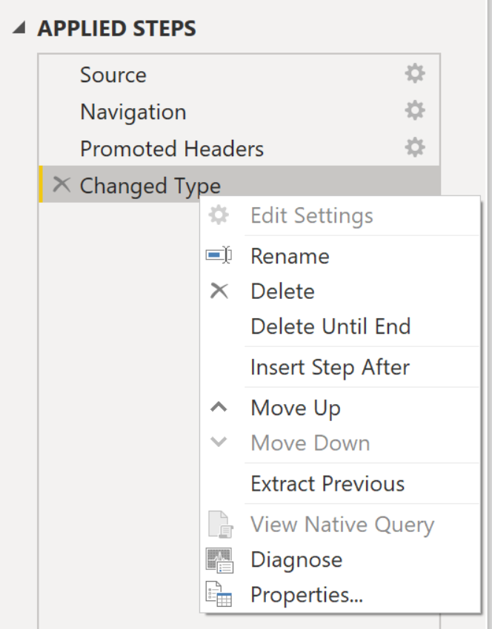

If the **View Native Query** option is not available (not displayed in bold type), that query folding is not possible for this step, and you will have to work backward in the Applied Steps area until you reach the step in which View Native Query is available (displays in bold type). This process will reveal the native query that is used to transform the dataset.

Native queries are not possible for the following transformations:

* Adding an index column
* Merging and appending columns of different tables with two different sources
* Changing the data type of a column
* Running complex DAX functions

A good guideline to remember is that if you can translate a transformation into a Select SQL statement, which includes operators and clauses such as GROUP BY, SORT BY, WHERE, UNION ALL, and JOIN, you can use query folding.

While query folding is one option to optimize performance when retrieving, importing, and preparing data, another option is query diagnostics discussed earlier.

### Knowledge Check

#### Question 1

Which storage mode leaves the data at the data source?

* Import
* Direct Query
* Dual

#### Question 2

Which technology improves performance by generating a single query statement to retrieve and transform source data?

* Query folding
* Adding index columns
* Adding custom columns with complex logic

## Resolve Data Errors

### Identify and resolve data import errors

While importing data into Power BI, you may encounter errors resulting from factors such as:

* Power BI imports from numerous data sources.
* Each data source might have dozens (and sometimes hundreds) of different error messages.
* Other components can cause errors, such as hard drives, networks, software services, and operating systems.
* Data can often not comply with any specific schema.

The following sections cover some of the more common error messages that you might encounter in Power BI.

#### Query timeout expired

Relational source systems often have many people who are concurrently using the same data in the same database. Some relational systems and their administrators seek to limit a user from monopolizing all hardware resources by setting a query timeout. These timeouts can be configured for any timespan, from as little as five seconds to as much as 30 minutes or more.

For instance, if you're pulling data from your organization's SQL Server, you might see the error shown in the following figure.

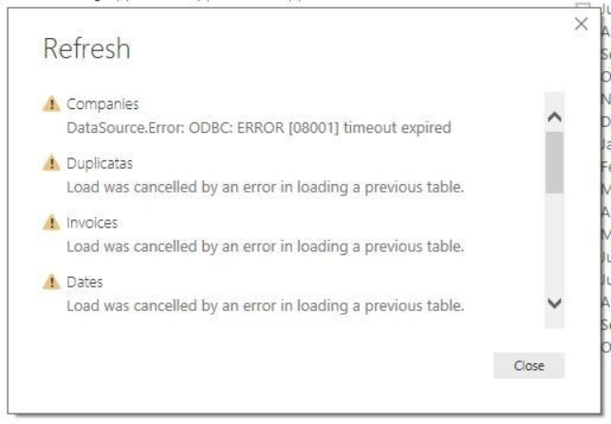

#### Power BI Query Error: Timeout expired

This error indicates that you've pulled too much data according to your organization's policies. Administrators incorporate this policy to avoid slowing down a different application or suite of applications that might also be using that database.

You can resolve this error by pulling fewer columns or rows from a single table. While you are writing SQL statements, it might be a common practice to include groupings and aggregations. You can also join multiple tables in a single SQL statement. Additionally, you can perform complicated subqueries and nested queries in a single statement. These complexities add to the query processing requirements of the relational system and can greatly elongate the time of implementation.

If you need the rows, columns, and complexity, consider taking small chunks of data and then bringing them back together by using Power Query. For instance, you can combine half the columns in one query and the other half in a different query. Power Query can merge those two queries back together after you are finished.

#### We couldn't find any data formatted as a table

Occasionally, you may encounter the “We couldn't find any data formatted as a table” error while importing data from Microsoft Excel. Fortunately, this error is self-explanatory. Power BI expects to find data formatted as a table from Excel. The error event tells you the resolution. Perform the following steps to resolve the issue:

1. Open your Excel workbook, and highlight the data that you want to import.
2. Press the Ctrl-T keyboard shortcut. The first row will likely be your column headers.
3. Verify that the column headers reflect how you want to name your columns. Then, try to import data from Excel again. This time, it should work.

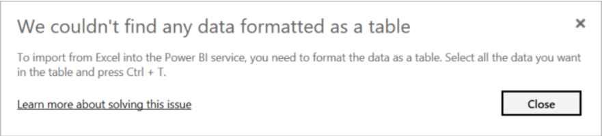

#### Could not find file

While importing data from a file, you may get the “Could not find file” error.

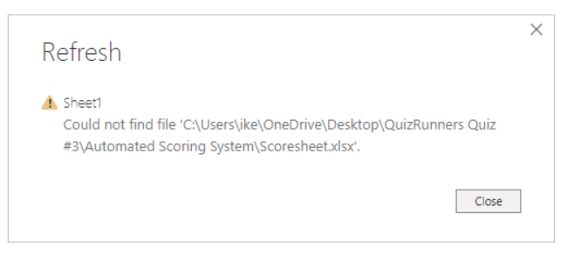

Usually, this error is caused by the file moving locations or the permissions to the file changing. If the cause is the former, you need to find the file and change the source settings.

1. Open Power Query by selecting the Transform Data button in Power BI.
2. Highlight the query that is creating the error.
3. On the left, under Query Settings, select the gear icon next to Source.

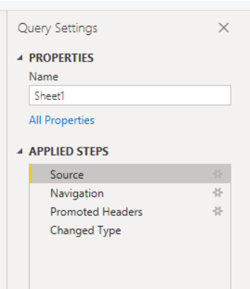

1. Change the file location to the new location.

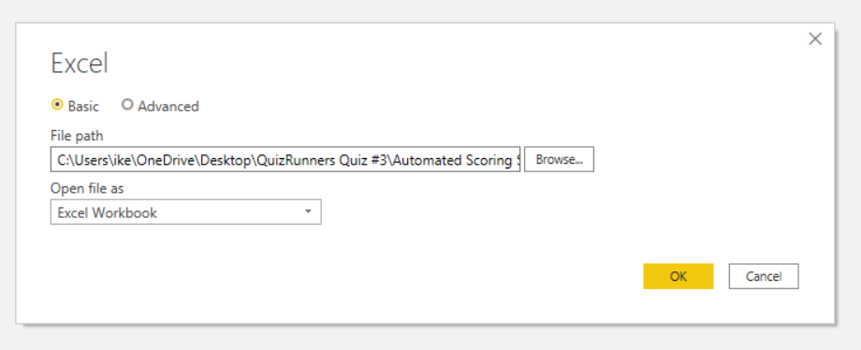

#### Data type errors

Sometimes, when you import data into Power BI, the columns appear blank. This situation happens because of an error in interpreting the data type in Power BI. The resolution to this error is unique to the data source. For instance, if you are importing data from SQL Server and see blank columns, you could try to convert to the correct data type in the query.

Instead of using this query:

SELECT CustomerPostalCode FROM Sales.Customers

Use this query:

SELECT CAST(CustomerPostalCode as varchar(10)) FROM Sales.Customers

By specifying the correct type at the data source, you eliminate many of these common data source errors.

You may encounter different types of errors in Power BI that are caused by the diverse data source systems where your data resides. If you encounter an error that was not discussed in the preceding sections, you can search Microsoft documentation for the error message to find the resolution you need.he preceding sections, you can search Microsoft documentation for the error message to find the resolution you need.

### Knowledge Check

#### Question 1

What type of import error might leave a column blank?

* Keep errors
* Unpivot columns
* Data type error

# Module 3 Clean, Transform, and Load Data in Power BI